ENGLISH
#stayathome
#everythingwillbeok
#wemissyou
Name:
Level:
Date:

Do you know the movie The Lion King? Have you seen it?
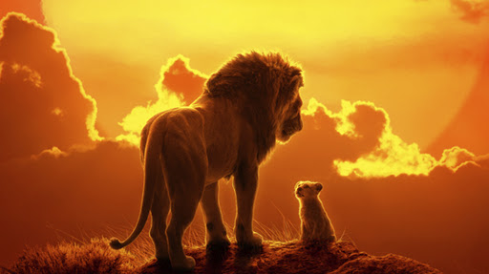
It’s the story of Simba, a little lion who is the son of the jungle king, Mufasa. Mufasa’s got a brother who is jealous of him and one day he tricks Simba to put his father in danger…

I’m sure all of you know the song I just can’t wait to be king in Spanish. Let’s watch the video and sing this cheerful song in English while filling the gaps. Then, answer the questions about it.

First, take a look at this new vocabulary and fill the gaps in the lyrics with them:
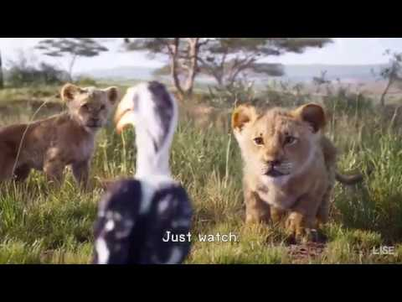
*Mighty: possessing great and impressive power or strength, especially because of size (poderós)
*Brush up on: to improve your knowledge of something already learned but partly forgotten (repassar)
*Horn-bill: a type of bird
*Heart to heart (to speak): candidly, intimately (parlar de cor a cor, íntimament)
*Go for broke: taking risks (arriscar-se)
*Herd: a large group of animals, especially mammals, that live together (manada)

I Just Can’t Wait to be King

I'm gonna be a ______ king
So enemies beware
Well, I've never seen a king or beast
With quite so little hair
I'm gonna be the main event
Like no king was before
I'm ________ __ __ looking down
I'm working on my roar
Thus far, a rather uninspiring thing
Oh, I just can't wait to be king
You've rather a long way to go, young master, if you think
No one saying, "do this"
Now when I said that, I
No one saying, "be there"
What I meant was
No one saying, "stop that"
Look, what you don't realize
No one saying, "see here"
Now see here!
Free to run around all day
Well, that's definitely out
Free to do it all my way
I think it's time that you and I
Arranged a _____ __ _____
Kings don't need advice
From little ____-_____ for a start
If this is where the monarchy is headed
Count me out
Out of service, out of Africa
I wouldn't hang about
This child is getting wildly out of wing
Oh, I just can't wait to be king
Everybody look left
Everybody look right
Everywhere you look I'm
Standin' in the spotlight
Not yet!
Let every creature __ ___ _____ and sing
Let's hear it in the ____ and on the wing
It's gonna be King Simba's finest fling
Oh, I just can't wait to be king
Oh, I just can't wait to be king
Oh, I just can't wait to be king

- Answer the questions:
- Who is Simba?
- Why does he want to be King?
- Zazu is his… friend / counsellor / enemy
- Nala is his… friend / counsellor / enemy
- If you were King or Queen, what would be the first thing you would do?

- Fill in the verbs with the correct present simple form:
- Mufasa ______ (be) the Lion King.
- Sarabi ______ (be) his wife.
- Mufasa and Sarabi ______ (have) a son.
- Their son’s name ______ (be) Simba.
- The animals ______ (be) afraid of Scar.
- Mufasa ______ (fall) from the cliffs.

- We use ‘I can’t wait’ when we are excited about something. For example:
I can’t wait to see the new Star Wars movie!
My sister can’t wait to go to the beach.
Dad can’t wait to celebrate Halloween.

Write your own sentence and draw a picture to go with it:

I can’t wait to…

