ENGLISH
#stayathome
#everythingwillbeok
#wemissyou
Name:
Level:
Date:

Do you know the movie Aladdin? Have you seen it?

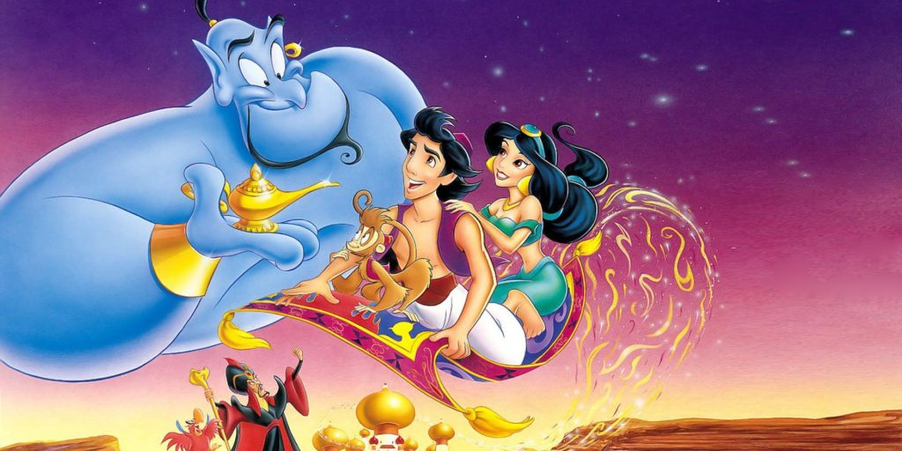
It’s the story of a poor boy and his monkey. One day, he meets a princess and falls in love with her. He finds a magic lamp and, inside this lamp, there is a genie. The Genie can do almost everything Aladdin can imagine, and he can be everything he wants.

Today we are going to review some jobs and occupations with the Genie!

I’m sure all of you know the song Friend Like Me in Spanish. Let’s watch the video and sing this cheerful song in English while filling the gaps. Then, answer the questions about it.

First, take a look at this new vocabulary and fill the gaps in the lyrics with them:

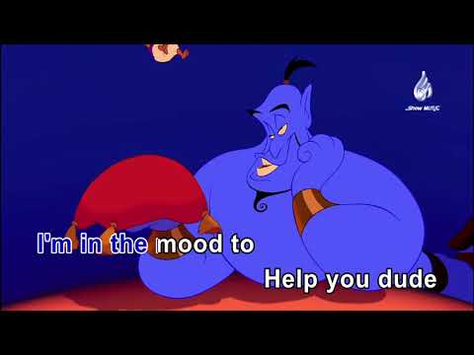
*Pizzazz: an attractive combination of vitality and glamour (dinamisme)
*Ammunition: a supply or quantity of bullets and shells (munició)
*Jot down: to write something (anotar)
*Dude: a man, a guy (un tipus, un paio, tio)
*Go poof: to vanish (desaparèixer)
*Sucker: a thing or person not specified by name (desconegut)

Friend Like Me

Well Ali Baba had them forty thieves
Scheherezad-ie had a thousand tales
But master you in luck 'cause up your sleeves
You got a brand of magic never fails
You got some power in your corner now
Some heavy __________ in your camp
You got some punch, __________, yahoo and how
See all you gotta do is rub that lamp
And I'll say
Mister Aladdin, sir
What will your pleasure be?
Let me take your order
___ it ____
You ain't never had a friend like me
Life is your restaurant
And I'm your maitre d'
C'mon whisper what it is you want
You ain't never had a friend like me
Yes sir, we pride ourselves on service
You're the boss
The king, the shah
Say what you wish
It's yours, true dish
How about a little more Baklava?
Have some of column A
Try all of column B
I'm in the mood to help you ____
You ain't never had a friend like me
Can your friends do this?
Do your friends do that?
Do your friends pull this out their little hat?
Can your friends __ ____?
Well, looky here
Can your friends go, Abracadabra, let 'er rip
And then make the ______ disappear?
So dontcha sit there slack-jawed, buggy-eyed
I'm here to answer all your midday prayers
You got me bona fide, certified
You got a genie for your chargé d'affaires
I got a powerful urge to help you out
So what-cha wish?
I really want to know
You got a list that's three miles long, no doubt
Well, all you gotta do is rub like so - and oh
Mister Aladdin, sir, have a wish or two or three
I'm on the job, you big nabob
You ain't never had a friend, never had a friend
You ain't never had a friend, never had a friend
You ain't never had a friend like me
You ain't never had a friend like me, hah!

- In the video, the Genie has many jobs. Can you remember all of them? Copy and paste this link in your explorer and play the Genie’s occupations game:

https://en.islcollective.com/video-lessons/aladdin-occupation-friend-me

And here you will find another lyrics game with the live-action video:

https://en.islcollective.com/video-lessons/will-smith-friend-like-me

- Read and answer:

- Where does the Genie live?
- How many wishes can he grant you?
- In the song, he pretends to be a… waiter / king / firefighter
- What would you like to be when you grow up? Why?
- What would be your wishes?

- In Aladdin there are different characters: Aladdin, the Genie, Abu, Jasmine… Describe your favourite one: talk about the physical appearance, the personality, interests, hobbies…

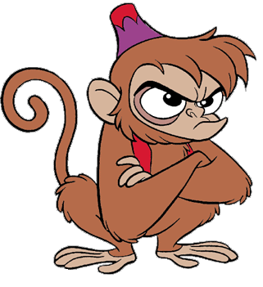
My Favourite Character

My favourite character is… (name). He/she is a boy/girl/monkey... He/She’s got…

