ENGLISH
#stayathome
#everythingwillbeok
#wemissyou
Name:
Level:
Date:

ANIMALS AND PARTS!

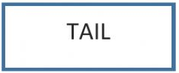
Do you remember the parts of the animals? Let’s do a little review to see how much you can recall

- Match the word with the picture:

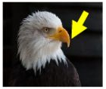
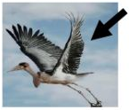
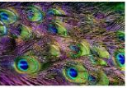
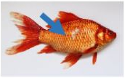
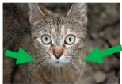
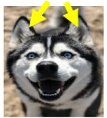
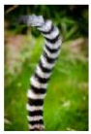
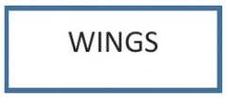
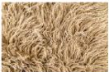
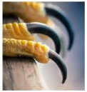

- Write T (true) or F (false):

- The cheetah has got wings.
- The bee has got stripes.
- The ladybird hasn’t got legs.
- The eagle hasn’t got a beak.
- The eagle has got feathers.
- The cheetah has got spots.

- Which animal is this? Write the name:
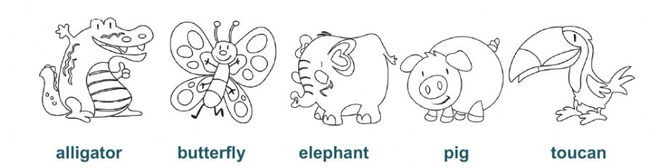

- It is small. It has got two wings, two legs, feathers and a big beak.
- It is big, fat and grey. It has got white tusks and a trunk.
- It is big and fat. It is pink. It has got four legs and a big snout.
- It is green. It has got four legs and a very big mouth.
- It is colourful. It has got wings. It has got six legs.

- Choose a word from the box:

Frog: It is _____ and small. It has got four _____. It has got a _____ mouth.

Spider: It _____ often black, _____ and fat. It has got _____ legs.

