ENGLISH
#stayathome
#everythingwillbeok
#wemissyou
Name:
Level:
Date:

WHAT DO YOU LIKE DOING?
We’ve been talking about hobbies and things we like doing. Today, I want you to think about free time activities that you like doing and others that you don’t. Do you like playing chess? Do you love reading? Do you enjoy dancing? Do you hate watching TV?
Make a list with different activities and rate them (love, enjoy, like, don’t like, hate). Here you can find a video with vocabulary about daily routines that can help you with the task. You can also look at the examples in tasks 2 and 3.

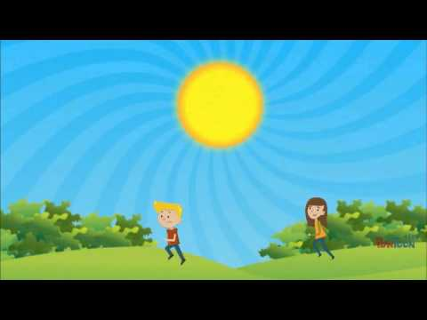
Once you have the text, send it to me so I can correct it. I will send it back to you for the second part of the task: to film a video explaining your hobbies and interests. To get you inspired, watch the following video. It’s similar to the previous one but it includes things that you don’t like doing. Record your own video explaining your interests.

LOVE | ENJOY | LIKE | DON’T LIKE | HATE
- Make a list with your hobbies and interests and the things you don’t like doing:

- Order your ideas and write what you are going to say in the video:

WHAT I LIKE DOING

Hello, my name is… I am… years old. I like… I don’t like… I love… I hate… I enjoy…

