ENGLISH
#stayathome
#everythingwillbeok
#wemissyou
Name:
Level:
Date:

A DAY IN MY LIFE
We’ve been talking about daily routines and things we usually do. Today, I’d like you to think about what you do in a normal day. At what time do you wake up? Do you usually go to school by walk or by car? Do you always do your homework in the afternoon? Do you sometimes play football in the weekend?
Write about a day in your life. Here you can find a video with vocabulary about daily routines that can help you with the task. You can also look at the examples in tasks 1 and 2 about a day in Emma’s and Stuart’s life.

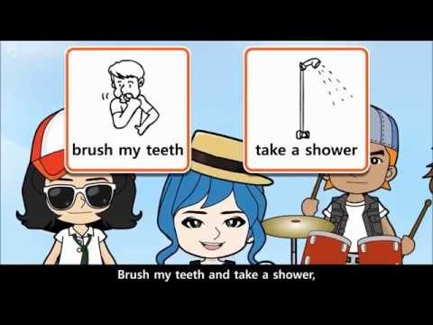
Once you have the text, send it to me so I can correct it. I will send it back to you for the second part of the task: to film a video explaining your daily routine. To get you inspired, watch the following video. It’s a song about a normal day in the life of the characters, but you don’t need to sing in the video if you don’t want to . Record it and explain what you do, taking the camera with you in your chores. Use the frequency adverbs we’ve learnt (always, usually, often, sometimes, rarely, never).

A DAY IN MY LIFE

Hello, my name is… I am… years old. My day usually starts at…

