ENGLISH
#stayathome
#everythingwillbeok
#wemissyou
Name:
Level:
Date:

WHAT I CAN DO

This week I want you to think about actions that you CAN do and others that you CAN’T. Can you jump? Can you climb? Can you stomp your feet?

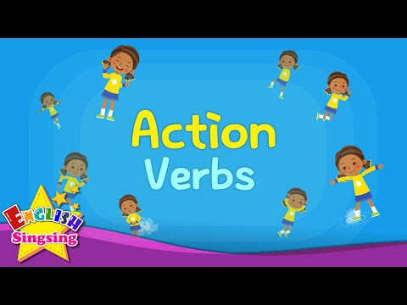
To help you, here there is a video with vocabulary to get you inspired. Watch it and continue reading!

Do you need more ideas? Learn this fun song

I think we’ve got a lot of ideas! Now, what you have to do is to fill this list with actions you can do and actions you can’t do.

I CAN | I CAN’T
Ready! Great! Now, for the last part of the task… Pick up your cameras! Record yourselves doing these things you can, and you can’t do, explaining what you do. For example: I can jump, but I can’t climb. I can run but I can’t dance…

Upload the video file to your Drive folder or send it by e-mail. Enjoy!

