Recipe Name:__________________ ____________________



**Students Name:**______________________________________

**Serves:** ________________________ **Prep Time**:___________________________ _______________________

**Ingredients**

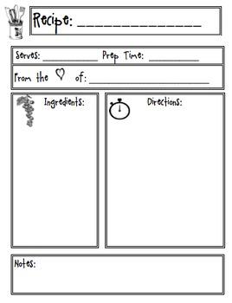

**Directions:**

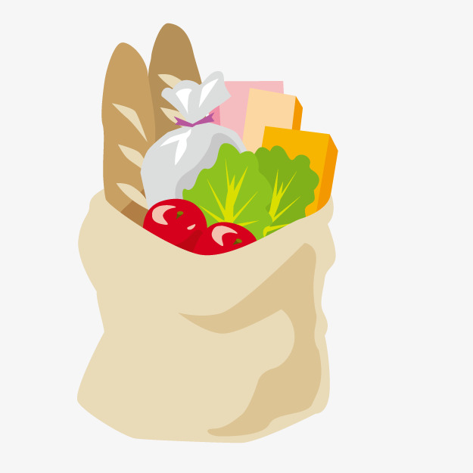



Insert Child Image Here