Recipe Name: Incredibly Delicious Banana Bread



**Students Name: Anna B.**

**Serves:** 4-5 servings **Prep Time**: 30 minutes _______________________

**Ingredients**

150 gr oat flour

50 gr ground almonds

2 ripe bananas

40 gr nuts

80 ml milk

1 tablespoon water

1/2 teaspoon baking powder

Vanilla essence

1 teaspoon cinnamon

2 eggs

1 egg white

Sweetener

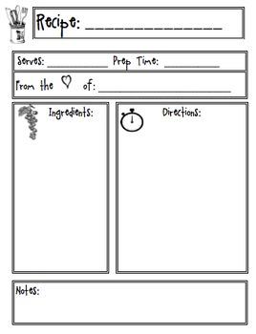

**Directions:**

Smash the bananas and mix them with the milk, the water, the eggs and the egg white.

In another bowl, mix the dry ingredients: the oat flour, the ground almonds, the cinnamon and the baking powder.

Blend the two mixtures and add a teaspoon of vanilla essence and the 40gr of nuts. Add as much sweetener as you want.

Pour the mixture into a baking pan and bake it in the oven for 20 minutes and 200º.

Enjoy! 😊





