ENGLISH
#stayathome
#everythingwillbeok
#wemissyou
Name:
Level:
Date:
STUART’S DAILY ROUTINE

My name is Stuart Minion and I am twelve. I have got a very big family and we are short and yellow. We are always happy!
I usually get up at seven o’clock and then I get dressed. I always have breakfast in the kitchen with my minion brothers, Tom and Darwin. I eat pancakes with honey, and I drink a banana milkshake. I catch the school bus at a quarter to eight and I go to school with Kevin and Bob. I love school! My teachers are the best.
I always have lunch, at midday, in the school canteen and my favourite is peanut butter sandwich and fruit salad with lots of banana slices.
At half past three, I go back home after classes and I do my homework with Dave, Carl and Larry. They are very smart. Sometimes, I play video games with Josh and Phil. They are my best friends. We never watch TV because we have so many things to play with.
Before dinner, I have a shower and at ten o’clock I brush my teeth and then, ten minutes later I go to bed.

- Write T (true) or F (false):

- The Minions are a big family.
- Stuart is twenty years old.
- Stuart has breakfast in the living room.
- For breakfast he eats sandwiches.
- Stuart always plays video games with Josh and Phil.

- Match the questions with the answers:

- Has he got a big family? | - No, they aren’t.
- Are they a sad family? | - Josh and Phil.
- Does he love school? | - In the school canteen.
- Where does he lunch? | - Yes, he has.
- Who are his best friends? | - Yes, he does.

- Choose the correct option:

- Stuart gets up at seven o’clock/eight o’clock.
- Stuart catches the school bus at a quarter to eight/a quarter past eight.
- He has lunch at eleven o’clock/at midday.
- He goes back home at half past two/half past three.
- He goes to bed at ten past two/ten past ten.

- What time is it? Match the pictures with the correct time:
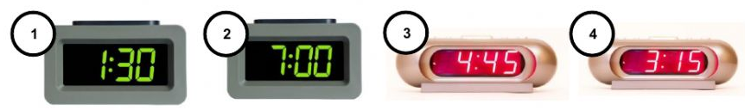

- It’s seven o’clock.
- It’s half past one.
- It’s a quarter past three.
- It’s a quarter to five.

- Choose the correct form of the verbs in present simple:

- Stuart listen/listens to music every day.
- Bob and Stuart has/have classes together.
- Stuart always study/studies very hard.
- Darwin doesn’t like/don’t like playing tennis after school.
- The teachers doesn’t teach/don’t teach at the weekend.
- Does Kevin do/Do Kevin do his homework? No, he doesn’t/don’t.
- Do they have/Does they have fun at school? Yes, they do/they does.
- Stuart doesn’t drink/don’t drink milk at breakfast.

- Look at the table and complete the sentences about Stuart’s daily routine.

 | Never | Sometimes | Usually | Always
Swim after school | X
Have piano lessons | X
Do his homework |  |  |  | X
Help his brothers at home |  |  | X
Talk to his friends |  | X

- Stuart never swims after school.
- Stuart _____ has piano lessons.
- He _____ does his homework.
- Stuart _____ help his brothers at home.
- He _____ talks to his friends.

