ENGLISH
#stayathome
#everythingwillbeok
#wemissyou
Name:
Level:
Date:

- Put the verbs in brackets into the -ing form:

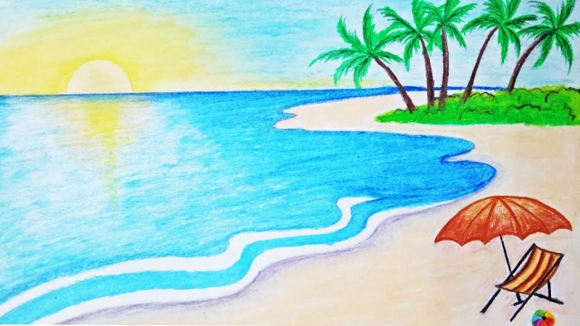
John and his family love _____ (go) to the beach in the summer. They like _____ (have) picnics and love _____ (sit) on the sand. John’s father hates _____ (make) sandwiches, so his mum always make them. John and his sister Fiona love _____ (play) with a big ball in the water. John’s father likes _____ (fish) and his mum loves _____ (read) magazines. John also likes _____ (listen) to music and _____ (play) videogames. John’s family like the beach because they like _____ (be) outdoors and _____ (watch) the people in the beach.

- Complete the dialogue with the correct form of the verbs:

MARTHA: Hi you two! What are you doing?
MYLES: We’re playing basketball. Do you want to play?
MARTHA: No, thanks. I __________ (not like/play) basketball.
JAMES: Wow! I __________ (love/play) basketball, it’s great!
MYLES: What do you __________ (like/do)?
MARTHA: Well, I __________ (like/ride).
JAMES: Yeah! That can be fun.
MARTHA: And I __________ (like/dance).
MYLES: Dancing! Oh, I __________ (hate/dance). I can’t dance.
MARTHA: That’s not true. Everyone can dance.
MYLES: Not me!
MARTHA: So I know you __________ (like/play) basketball, but what else do you __________ (like/do)?
MYLES: I __________ (like/play) chess.
JAMES: Chess! That’s boring.

- Write T (true) or F (false):

- James likes playing basketball.
- Martha likes playing basketball.
- She likes riding.
- James likes riding.
- Myles doesn’t like dancing.
- James likes playing chess.

- Write affirmative sentences. Then, write negative sentences and questions:

Affirmative sentences
I like  You like  He likes  She likes  We like  You like  They like | dancing (dance)  __________ (paint)  __________ (fish)  __________ (swim)  __________ (ride)  __________ (cook)  __________ (sing)
Negative sentences
I don’t like  You ______  He ______  She ______  We ______  You ______  They _____ | dancing (dance)  __________ (paint)  __________ (fish)  __________ (swim)  __________ (ride)  __________ (cook)  __________ (sing)
Questions and answers
Do I like  __ you ____  __ he ____  __ she ____  __ we ____  __ you ____  __ they ___ | dancing (dance) – Yes, I do/No, I don’t  __________ (paint)  __________ (fish)  __________ (swim)  __________ (ride)  __________ (cook)  __________ (sing)

