ENGLISH
#stayathome
#everythingwillbeok
#wemissyou
Name:
Level:
Date:

Hello, everybody! This is Tom. Tom goes to school every day and he studies a lot. Here is Tom’s timetable. Look carefully at it and answer the questions. Please, remember to write full sentences and to write the time in words, not numbers
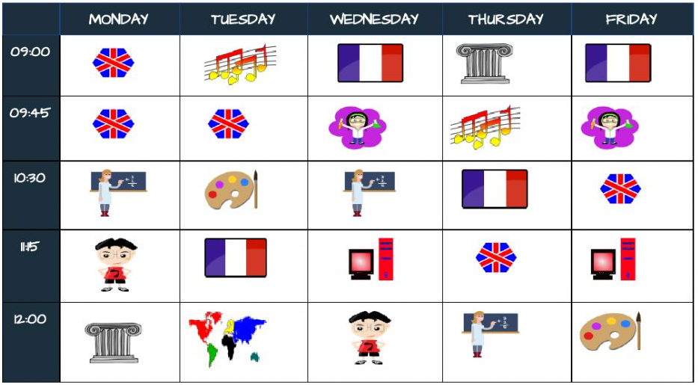

- Has he got English on Wednesdays? ________________________
- Has he got French on Fridays? ________________________
- Has he got Science at 9:45 on Wednesdays? __________________
- What has Tom got at 12 o’clock on Tuesdays? _________________
- Has he got ICT at 10:30 on Thursdays? ______________________
- At what time has Tom got Music on Tuesdays? ________________
- Has he got P.E. at 11:15? ________________________
- When has he got Art and Design? ________________________
- Has he got Maths on Wednesdays? ________________________
- Has he got History at 9:00 on Tuesdays? _____________________
Now, look at what Tom likes and what he doesn’t like and write about it.

We’ve got a new situation at school and we had to change our timetables. What is your new timetable? What subjects have you got? What days? At what time do you do your tasks? What are your favourite subjects?

