ENGLISH
#stayathome
#everythingwillbeok
#wemissyou
Name:
Level:
Date:

LIKE + Verb -ing

We use the verb like + verb-ing (ending in ing) to say how we feel about an activity, what you like doing in general: our hobbies and free time activities.

I like playing cards.
I like juggling.
I like collecting stamps.

We can also use other verbs to express our likes and dislikes: love, enjoy, don’t mind, don’t like, hate.

I love reading in bed at night.
I enjoy playing video games.
I don’t like getting up early.
I hate washing the dishes.

Remember! I like cooking.
I like to cooking.

- Negative sentences with like:

Subject + don’t/doesn’t + like + Verb -ing
I don’t like writing essays.
I don’t like waiting.
He doesn’t like eating spinach
- Negative sentences with hate:

Subject + hate + Verb -ing
I hate writing essays.
I hate waiting.
He hates eating spinach
- Questions with like:

Do/Does + subject + like + Verb -ing
Do they like playing chess?
Does she like baking cakes?
Do you like blowing bubbles?
And don’t forget…

If the verb ends in -e, we drop it (make - making)
If the verb ends in vowel + consonant + vowel, we double the last consonant (hit - hitting)
Now, let’s practice a bit!

- Complete the sentences with the correct form of the verbs in brackets:
a. I ___________________ basketball on TV. (watch/love)
b. He ___________________ to school in the morning. (don’t mind/cycle)
c. My sister ___________________ in the park. (run/love)
d. We ___________________ football in the rain. (play/not like)
e. Jessie ___________________ team sports. (do/hate)
f. Max and Lisa ___________________ in the sea. (swim/enjoy)
g. My dad ___________________ his car in the city. (drive/hate)
h. She ___________________ up early in the morning. (get/not like)
i. My friends ___________________ football on Saturday. (play/love)
j. My sister ___________________ out with friends. (go/love)
k. Julie ___________________ long books for school. (read/don’t mind)
l. Children ___________________ to the park. (go/love)

- Write sentences with different subjects (I, you, he…). Use love, like, hate…

_________________________ _________________________
_________________________ __________________________

_________________________ _________________________
_________________________ __________________________

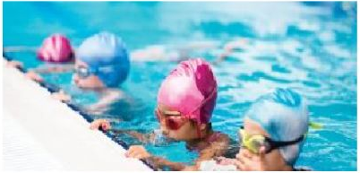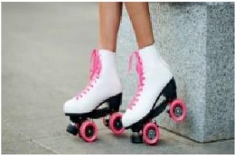
_________________________ _________________________
_________________________ __________________________

- Write the sentences properly:

- Paul/like/eat/snails _______________________________________
- Jenny/not like/play/cricket ________________________________
- My little brothers/love/watch/TV ____________________________
- You/hate/clean/your bedroom _____________________________
- Teenagers/love/listen/to music ____________________________
- Our dad/not like/wear/hats ________________________________
- He/prefer/wear/caps ______________________________________
- My grandfather/not like/drive/his car ________________________
- We/hate/drink/milk _______________________________________
- Marc/not like/study/maths _________________________________

- Write questions and answers:

- Michelle/make/her bed
(like) ____________________________________
(no, not like) _______________________________________
- The turtle/run
(like) _______________________________________
(no, hate) _______________________________________

