ENGLISH
#stayathome
#everythingwillbeok
#wemissyou
Name:
Level:
Date:

What do they do? Match the pictures with the activities:

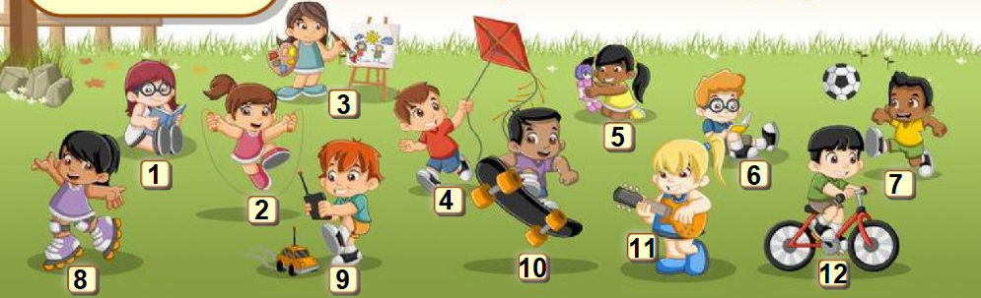

- Paint pictures ___
- Play with a doll ___
- Rollerblade ___
- Play football ___
- Read a book ___
- Fly a kite ___
- Skateboard ___
- Play the guitar ___
- Skip ___
- Ride a bike ___
- Play with a car ___

Look at the pictures and answer ‘Yes, I do’ or ‘No, I don’t’:

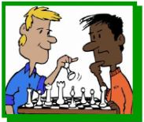

Do you paint pictures? Do you play video games?
_____________________ _____________________
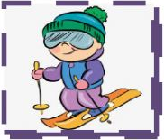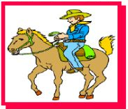

Do you ride a bike? Do you ride a horse?
_____________________ _____________________

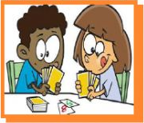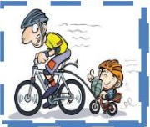

Do you play cards? Do you skateboard?
_____________________ _____________________

Do you play board games? Do you watch TV?
_____________________ _____________________

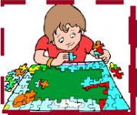

Do you row? Do you do puzzles?
_____________________ _____________________

