ENGLISH
#stayathome
#everythingwillbeok
#wemissyou
Name:
Level:
Date:

ADVERBS OF FREQUENCY

We use some adverbs to describe how frequently we do an activity.

- The position of the adverb in a sentence

- An adverb of frequency goes before a main verb (except with ‘to be’).

Subject + adverb + main verb
I always remember to do my homework.
He usually gets good marks in exams.

- An adverb of frequency goes after the verb ‘to be’.
Subject + to be + adverb
They are never happy.
She isn’t usually bad tempered.

- We can use some adverbs at the start of a sentence: usually, often, sometimes

- But we can’t use the following at the beginning of a sentence: always, rarely, never

- We use never with positive verbs, not negative:

She never comes to my parties
They never say ‘thank you’.
Now, let’s practice a bit!

- Match the adverbs with the frequency
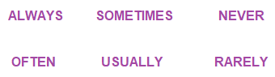
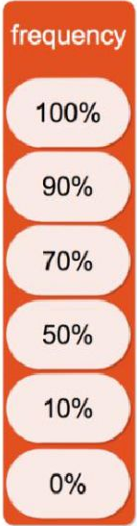

_________________________

_________________________

_________________________

_________________________

_________________________

_________________________

- Read about Emma’s daily routine and answers the questions:
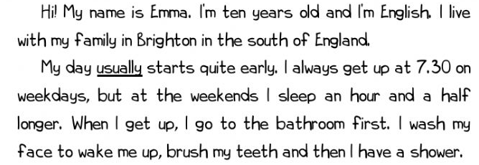

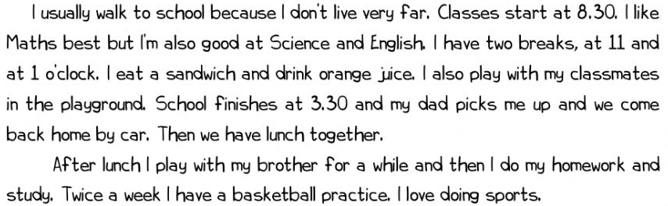
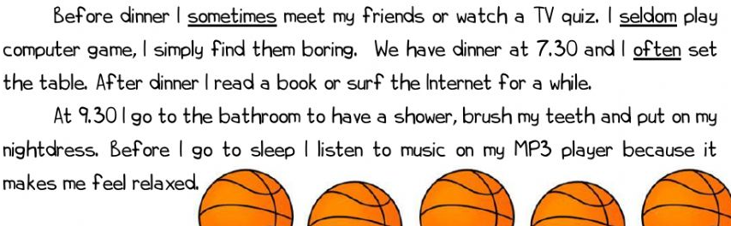

- What happens at these hours?

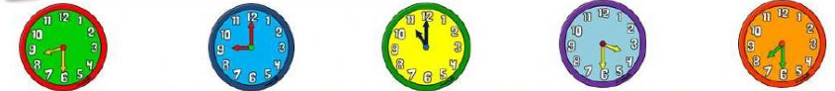

- At half past eight, Emma starts school.
- At nine o’clock…
- At…
- At…
- At…

- Answer the questions about Emma. Write sentences:

- How old is Emma? _____________________________
- Where does she live? ___________________________
- How many brothers and sisters has she got? ________________
- What kind of clothes does she like? ________________________
- What does she have for breakfast? _________________________
- How does Emma usually get to school? _____________________
- Where does she spend her breaks? ________________________
- What time do classes finish? _____________________________
- Where does she go twice a week? __________________________
- What does she do after dinner? ____________________________

- Put the words in order to make sentences:

- for/never/I/school/late/am ___________________________
- have/Tuesdays/Spanish/On/we ________________________
- dad/work/car/often/my/to/by/goes _____________________
- my/I/with/always/housework/help/mum/the ______________
- once/judo/week/She/a/has/classes _____________________
- like/very/gardening/I/much ___________________________

As you may know, tomorrow we celebrate Saint George’s day. On this day, men give roses to their beloved and women give them a book in return, as a sign of their love. This tradition comes from the legend of Saint George, in which the knight killed the dragon to save the princess and, from its blood, roses grew.

Listen to the legend of Saint George and then you can do these fun activities in JClic. Hope you enjoy it. Have a nice St. George’s day!

https://clic.xtec.cat/projects/sjordien/jclic.js/index.html

*CS: select ‘Third Cycle Activities’

