ENGLISH
#stayathome
#everythingwillbeok
#wemissyou
Name:
Level:
Date:

THIS WEDNESDAY WE PLAY… KARAOKE!

This week I propose you to do something different and fun as a warmup: let’s play karaoke!
We are going to sing Perfect, by Ed Sheeran. First, read carefully the following article about why Ed composed the song and answer the questions.

https://www.smoothradio.com/features/ed-sheeran-perfect-meaning-lyrics-video/

- What is the song about?
- The love for his family.
- The love for his pets.
- The love of his life.

- What kind of song is it?
- A rock song.
- A ballad.
- A hip-hop version.

- What does barefoot mean? ________________________________

- For Ed, Perfect is…
- The best love song of his career
- Another ballad about love
- Mortally boring

- Someone in Ed’s family helped him with the song. It was…
- His father
- His brother
- His grandmother

- What is your favourite music genre? Why? Who is your favourite singer/group?

Now, you can log in lyricstraining.com and play karaoke. To do so, you should register at the following web:
https://es.lyricstraining.com/

It’s free and you can practice English singing all the songs you want.
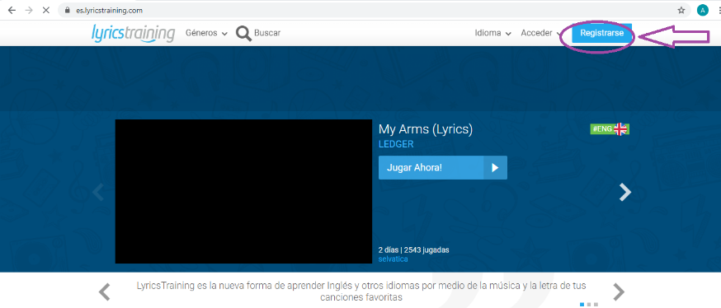

You can register here

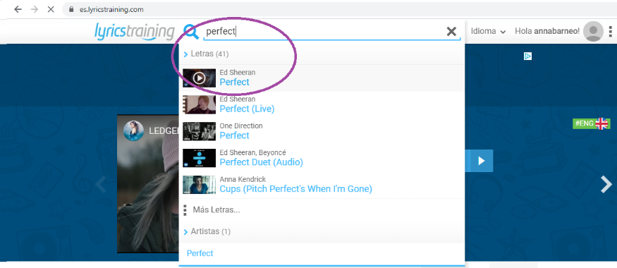
Once you have an account, type the name of the song and click:

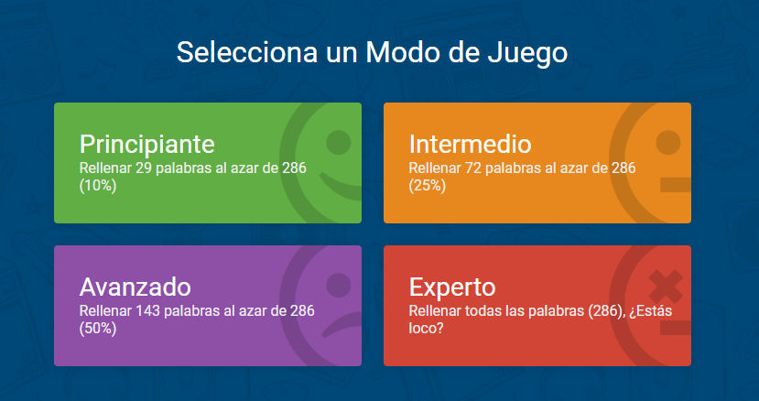

You can choose between different levels of difficulty. The aim is to fill the gaps in the song

To finish, decide if you want to write the missing words or choose them from a list and… let’s play!

What score did you get? What level did you choose? Tell me about it!

