ENGLISH
#stayathome
#everythingwillbeok
#wemissyou
Name:
Level:
Date:

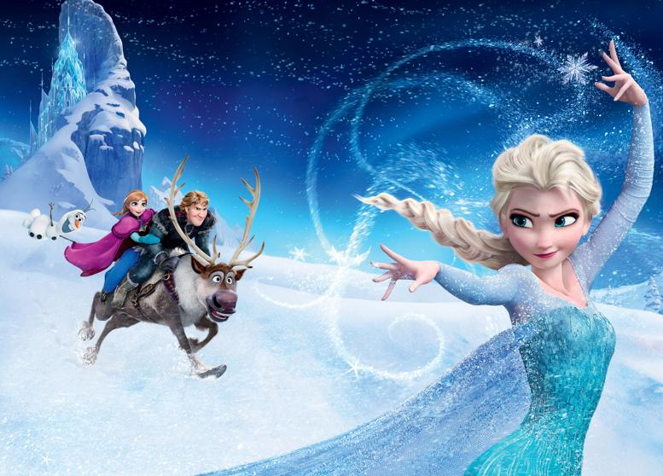
Do you know the movie Frozen? Have you seen it?

It’s the story of two sisters, Elsa and Anna. Elsa is the queen of Arendelle and has magical powers: she can control the ice. She wants to keep the secret but… one day, all the kingdom discovers it! Elsa is very worried and runs away…

Today, we are going to practice some English with Elsa!

I’m sure all of you know the song Let it go! in Spanish. Let’s watch the video and sing this beautiful song in English. Then, answer the questions about it.

First, take a look at this new vocabulary. It’s very important in the song:

*Howl: To make a loud sound, like wolves and dogs do (udolar)
*Swirl: To move quickly with a circular movement (fer remolins)
*Glow: To produce a light (resplendir, brillar)
*Conceal: Hide something (amagar)
*Hold back: To not do something, often because of fear (contenir-se)
*Blast: To explode or destroy something (explotar)
*Bother: To worry about something (preocupar-se)

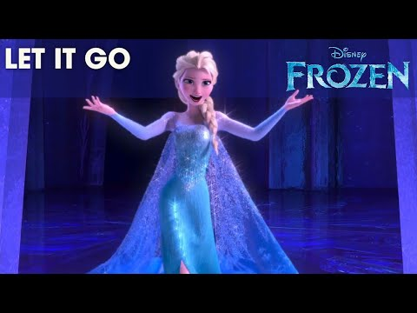
- Fill the gaps in the song with the words in blue:

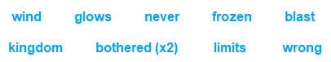

The snow ______ white on the mountain tonight
Not a footprint to be seen
A ______ of isolation
And it looks like I'm the queen
The ______ is howling like this swirling storm inside
Couldn't keep it in, heaven knows I've tried
Don't let them in, don't let them see
Be the good girl you always have to be
Conceal, don't feel, don't let them know
Well, now they know
Let it go, let it go
Can't hold it back anymore
Let it go, let it go
Turn away and slam the door
I don't care what they're going to say
Let the storm rage on
The cold never ______ me anyway

It's funny how some distance makes everything seem small
And the fears that once controlled me can't get to me at all
It's time to see what I can do
To test the ______ and break through
No right, no ______, no rules for me
I'm free
Let it go, let it go
I am one with the wind and sky
Let it go, let it go
You'll ______ see me cry
Here I stand and here I stay
Let the storm rage on

My power flurries through the air into the ground
My soul is spiraling in ______ fractals all around
And one thought crystallizes like an icy ______
I'm never going back, the past is in the past
Let it go
The cold never ______ me anyway
Let it go, let it go
And I'll rise like the break of dawn
Let it go, let it go
That perfect girl is gone
Here I stand in the light of day
Let the storm rage on
The cold never bothered me anyway

- Circle or underline the correct answer:

- Is Elsa a princess? Yes, she is/No, she isn’t
- The snow rages/howls/glows
- The wind rages/howls/glows
- The storm rages/howls/glows
- What is Elsa’s secret? She’s got powers/She sings very well
- Is she bothered about the cold? Yes, she is/No, she isn’t

- In Frozen, there are different characters: Elsa, Anna, Klaus, Olaf, Hans… Describe your favourite one! What is his/her name? Is it a boy or a girl? How is his/her hair? What colour are his/her eyes? You can add a picture of the character.

My Favourite Character
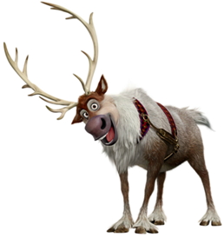
My favourite character is… (name). He/she is a boy/girl. He/She’s got…

