ENGLISH
#stayathome
#everythingwillbeok
#wemissyou
Name:
Level:
Date:
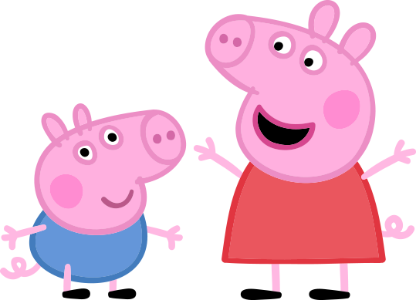

I’m sure you all know Peppa Pig and her family. Today we are going to watch a story about Mummy Pig’s birthday.

Click on the picture to watch this Peppa’s episode:
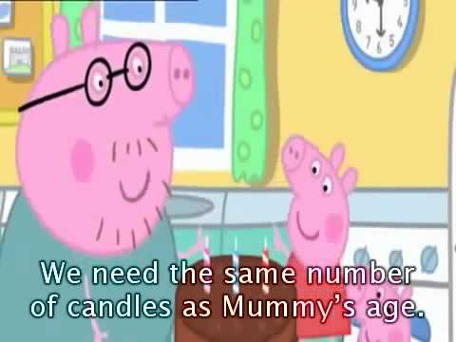

Now, you are ready to circle or underline the correct answer:

- Peppa and George make Mummy Pig a…
- Birthday cake.
- Birthday card.
- Birthday present.
- Daddy Pig makes Mummy Pig a…
- Birthday breakfast in bed.
- Birthday lunch in the garden.
- Birthday supper in a restaurant.
- Peppa says ‘yummy’ because the cake is…
- Terrible.
- Disgusting.
- Delicious.
- How many candles are there in the cake?
- Three.
- Four.
- Five.
- Mummy Pig’s present is…
- A beautiful dress and two tickets for the theatre.
- A beautiful skirt and two tickets for the cinema.
- A beautiful blouse and two tickets for the museum.

2. Tell me about you. When is your birthday? Is it in spring, summer, autumn or winter? Do you get many presents? Do you celebrate a birthday party like Mummy Pig?

My name is… My birthday is in the… (winter, summer…). I get lots of presents/a few presents. I celebrate/don’t celebrate a birthday party.

