
ENGLISH 4th Grade 8th June
Good morning!!! How are you? Hope you are great!

These are the activities for you to do during this week

REMEMBER ! SEND THE ACTIVITIES TO ME: PilarGA@josepferra.com
BEFORE SUNDAY 14th JUNE

1. ACTIVITY 1 : WAVING HANDS .
Instructions:
1. Draw your hand on a piece of paper .
2. Write your name in the centre
3. In each finger, write a wish for the summer . In English , of course !!!
4. Decorate your hand.
3. Take a photo and send it to me.
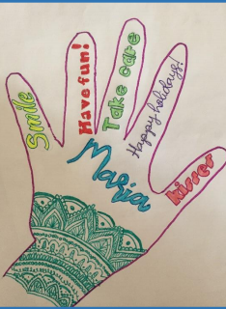
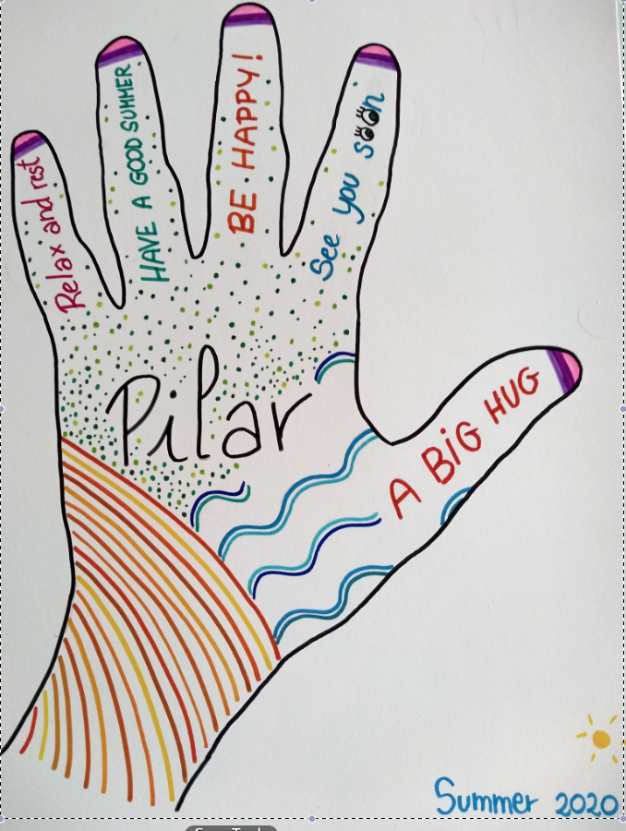
Example :

What can you write in it ? Here you have some ideas . Match them

Lots of Laughs! Que tinguis el millor estiu
Have a perfect holiday ! Sigues un bon amic
See you in September Molta diversió per a tu
Be a good friend Sigues bo i dolç
Lots of fun for you Que t’ho passis molt bé
Be nice and sweet Moltes rialles
Have a good time Que tinguis unes vacances perfectes
Have the best summer Fins el Setembre

Or you can write your own messages! BE CREATIVE !
You can use the dictionary .

2. ACTIVITY 2 : Write an Acrostic poem

Read these poems :
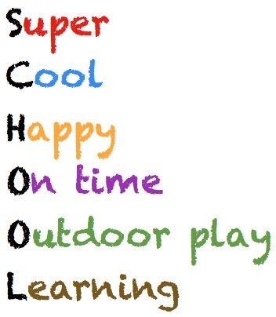

Sounds of
Children all around.
Happy time
Oh, now we miss you,
On our boring days
Learning alone at home


Blue water
Endless waves
Amazing place
Calm or busy
Happy Day!!!!

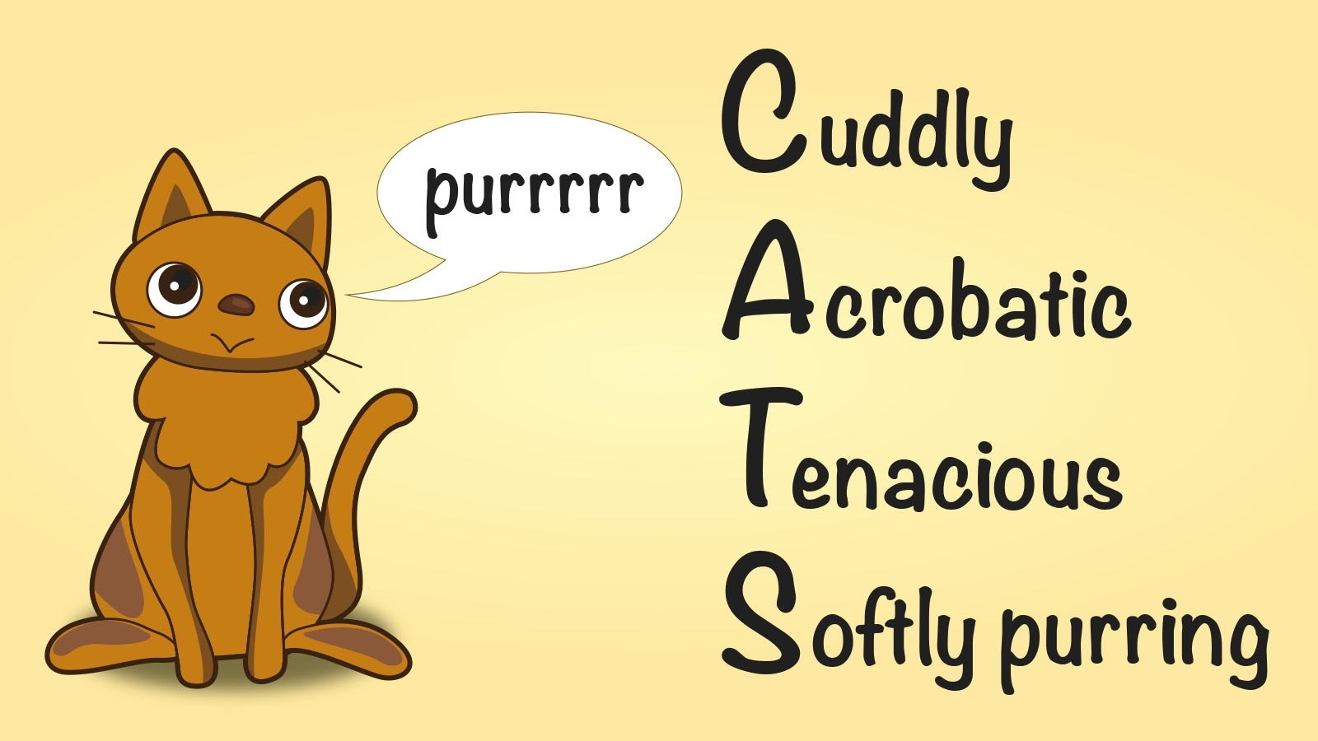

Can you make a poem? You can use words like
SUMMER, HOLIDAYS, SEA, HOME , COUNTRYSIDE , SWIMMING POOL, FRIEND , BROTHER, SISTER, MUM, DAD,GRANDMA, GRANDPA , your dog’s name..... or whatever word you like !

HAVE A GO AND
send your poems to me !!!

Have a nice week!

