
ENGLISH 4th Grade 25th May

Good morning!!! How are you? Hope you are great!

Here you have the activities for this week!!

REMEMBER ! SEND THE ACTIVITIES TO ME: PilarGA@josepferra.com
BEFORE SUNDAY 31st May

1. WATCH THIS STORIES FOR INSPIRATION or just for fun !!!

https://elt.oup.com/student/oupeprimary/traditional-tales?cc=global&selLanguage=en#tracktitle

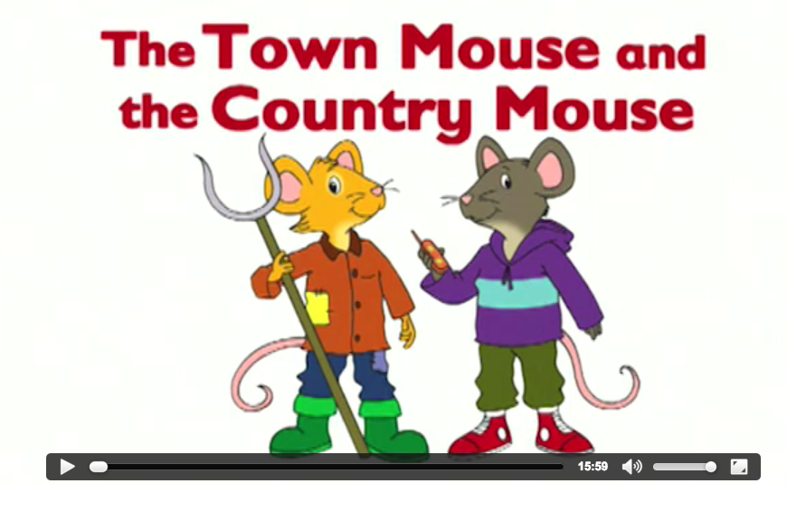
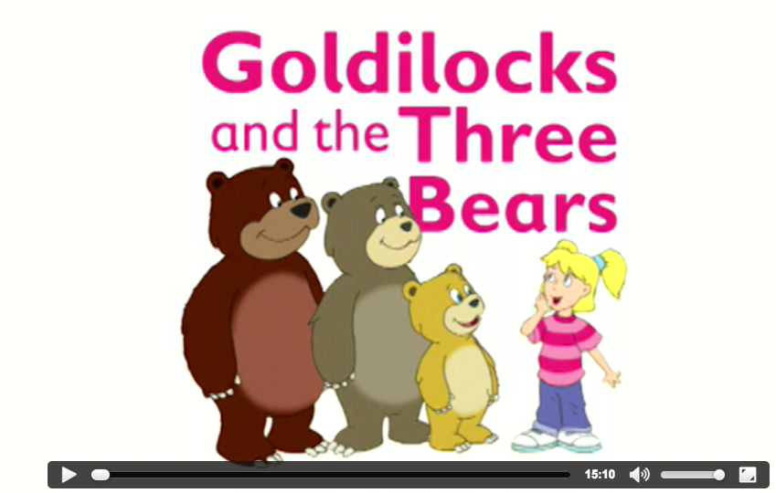

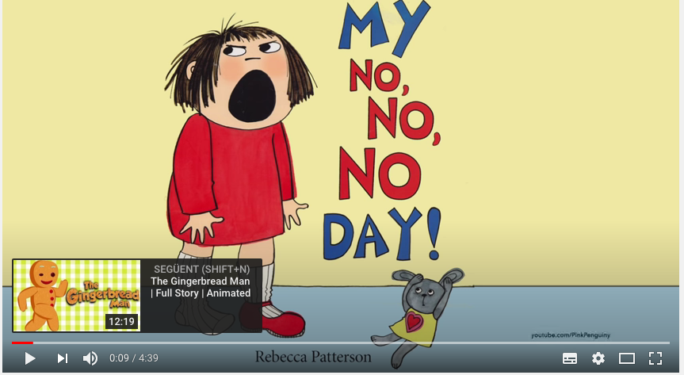

https://www.youtube.com/watch?v=x-Bpoj5fZr0

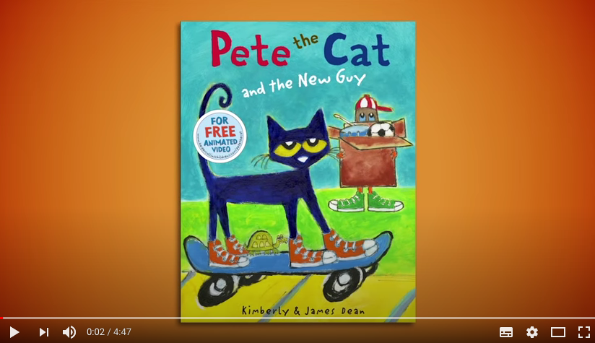

https://www.youtube.com/watch?v=W42oHAqM9N8

2. COMPLETE . Give opinions:
- I like this story because it’s ...
- I don ‘t like this story because ...

USEFUL WORDS FOR YOUR OPINION :
interesting / boring/ entertaining/ traditional/ creative/ sweet/ original/ amazing / exciting / slow/ fun / imaginative / real / it makes you think /

NAME : |  |  | CLASS:
STORY TITLE | DIFFICULT/ EASY | RATE  /10 | YOUR OPINION *
Example : Pete the Cat and the new guy | Medium | 8 | I like this story because it is musical and fun

3. . WATCH A VIDEO : HOW TO MAKE A PUPPET

https://learnenglishkids.britishcouncil.org/how-videos/how-make-stick-puppet

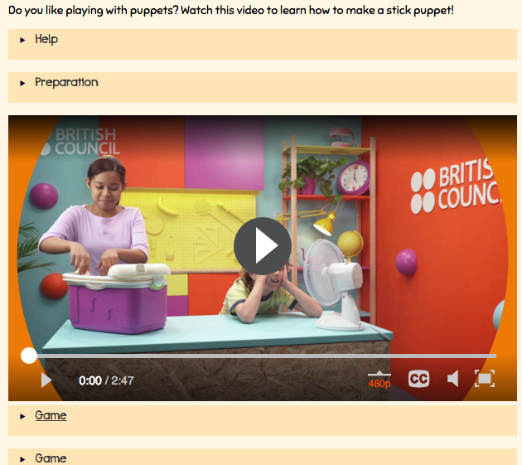
D
2..Watch the video
1. Do the preparation activity first

3. Do the games on -line

Take a screenshot or a photo of you activities and send it to me

4. MAKE YOUR PUPPET OR PUPPETS

Make your puppets. You can make people or animals .

3. MAKE YOUR PUPPETS SPEAK

Create a story or a dialogue in English and make your puppets speak . You can invent a dialogue or tell just just your puppet’s name,, and favourite things, as in the example:

My name is Pete. I am a cat. I like music very much, specially rock and roll.
I like climbing trees and playing with my friends.
I don’t like being sad. ( or blue *, but I AM BLUE !!!!) .

* I am blue = I am sad, = I am not happy

RECORD A VIDEO and send it to ME .

PRACTICE AND RECORD YOUR PUPPET VIDEO SHOW ON VIDEO

SEND IT TO ME : PilarGA@josepferra.com

