
ENGLISH 4th Grade 18th May

Good morning!!! How are you? Hope you are great!

Here you have the activities for this week!!

REMEMBER : DON’T SEND THE HOMEWORK, just keep it

1. GAMES to practice on-line.

https://www.liveworksheets.com/vp261911le

2. ACTIVITY 2 : CREATE AND READ your own story

https://learnenglishkids.britishcouncil.org/games/story-maker-1

You can create different stories and read them.
You can print your favourite one and illustrate it

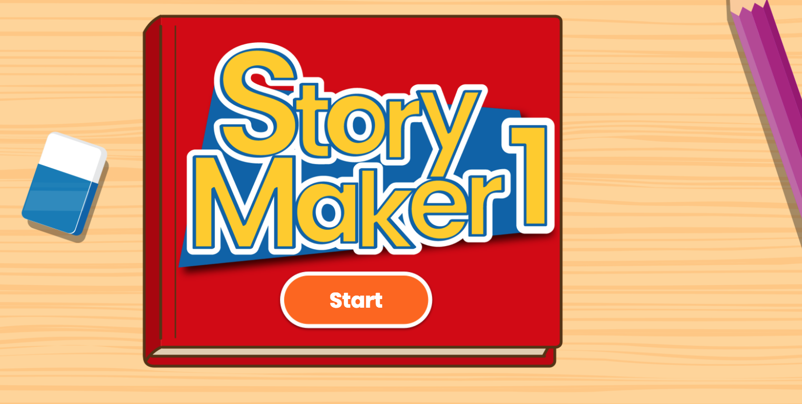

3. ACTIVITY 3 : WATCH THE STORY The pirates’ treasure

https://elt.oup.com/student/amazingrooftops/level04/stories?cc=global&selLanguage=en#tracktitle

Complete the next page
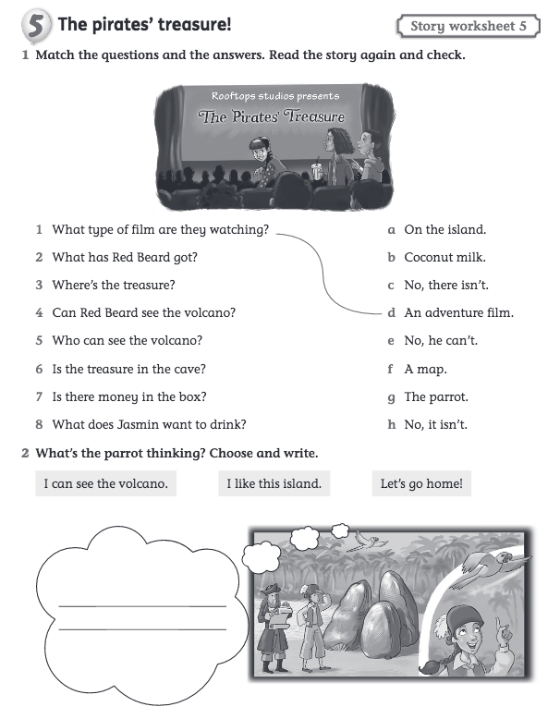
HAVE A NICE WEEK !

