
ENGLISH 4th Grade 11th May

Good morning!!! How are you? Hope you are great!

Here you have the activities for this week!!

REMEMBER ! SEND THE ACTIVITIES TO ME: PilarGA@josepferra.com
Aquesta setmana heu d’enviar les tasques abans del diumenge 17 de maig

1. GAMES to practice on-line. NOT NECESSARY TO SEND ANYTHING

https://assets.cambridgeenglish.org/activities-for-children/s-l-01-storyline-output/story.html?_ga=2.20512125.452216091.1588613192-1483408734.1584728985

https://assets.cambridgeenglish.org/activities-for-children/s-l-03-storyline-output/story.html?_ga=2.87499485.452216091.1588613192-1483408734.1584728985

2. REVIEW and ANSWER
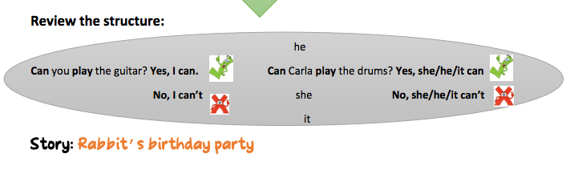

https://es.islcollective.com/video-lessons/interactive-story-cancant

Watch and answer the interactive questions


Complete with : Yes, it can or No, it can’t

Can the monkey dance? ___________________________
Can the Black bird fly? ____________________________
Can the rabbit jump?_____________________________
Can the rabbit swim ? _____________________________

3. ACTIVITIES TO PRACTICE ON –LINE.

When you finish, click the button FINISH, then CHECK my answers and you will have the exercises corrected. ( The green is OK, the red is not good enough), and a mark with a number. TAKE A PHOTO and SEND IT TO ME

https://www.liveworksheets.com/worksheets/en/English_as_a_Second_Language_(ESL)/Telling_the_time/What's_the_time$_-_listening_qo7385sz TAKE A PHOTO and SEND IT TO ME

https://www.liveworksheets.com/worksheets/en/English_as_a_Second_Language_(ESL)/Like_%5E_ing/Free_time_activities*listening_nr49663fa
TAKE A PHOTO and SEND IT TO ME

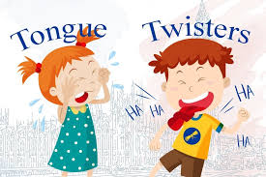

4. TONGUE TWISTERS

Do you know any tongue twisters?
They are sentences difficult to pronounce.
They usually have sense, but it’s hard to say them fast.

WATCH THE VIDEO and READ PAYING ATTENTION TO THE PRONUNCIATION .

https://www.youtube.com/watch?v=FUkCm2_8ncA



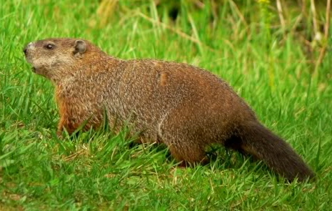
1. How much wood would a woodchuck chuck
if a woodchuck could chuck wood?
A woodchuck, una marmota
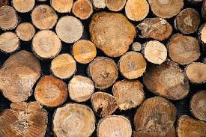
(CATALAN :
Quanta fusta llançaria una marmota
Si una marmota pogués llançar fusta?

wood
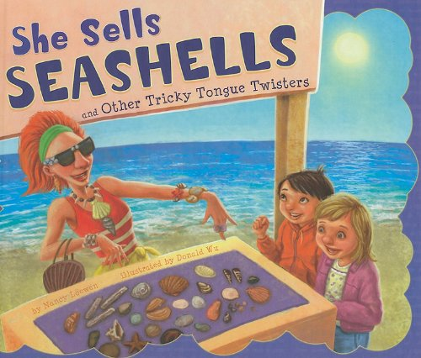
2. She sells seashells by the seashore
(CATALAN :
Ella ven petxines a la vora del mar),

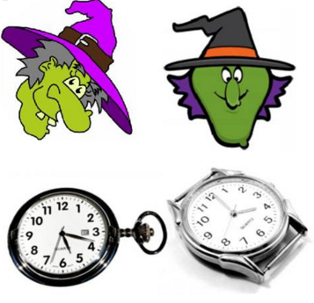
3. If two witches were watching two watches ,
which witch would watch which watch?
(CATALAN :
Si dues bruixes estaven mirant dos rellotges,
quina bruixa miraria quin rellotge?.
Two witches watching two watches


4. Give papa a cup of proper coffee
in a copper coffee cup
(CATALAN :
Dona-li al papa una tassa de bon cafè
en una tassa de cafè de coure)
A copper coffee cup

PRACTICE AND RECORD YOUR TONGUE TIWSTERS ( at least one)
ON AUDIO OR VIDEO

SEND IT TO ME : PilarGA@josepferra.com

