
4th May
ENGLISH 4th Grade

Good morning!!! How are you? Hope you are great!
I liked your videos very much!!!
Here you have the activities for this week!!
REMEMBER: IT’S NOT NECESSARY TO SEND ANYTHING TO ME
Aquesta setmana no heu d’enviar tasques
Games :
https://www.gamestolearnenglish.com/vocab-game/ (Choose Animals 1)
https://www.gamestolearnenglish.com/telling-the-time/
https://www.liveworksheets.com/worksheets/en/English_as_a_Second_Language_(ESL)/Prepositions_of_place/Prepositions_of_place_-_listening_exercise_sf7167cf


Kahoot!:
https://kahoot.it/challenge/03494823?challenge-id=76502422-0318-440c-9483-f92e476ce6b9_1588321907233
(Write your name and class before playing)
Escriu el teu nom i classe abans de jugar
Quizlet:
https://quizlet.com/_8d0tmh?x=1jqt&i=2uldj5
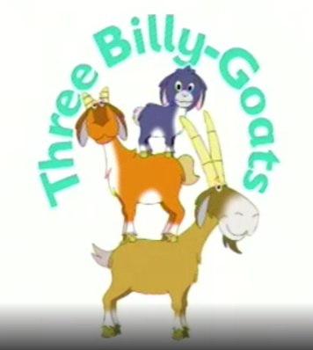
Story: Three Billy Goats
https://elt.oup.com/student/oupeprimary/traditional-tales?cc=global&selLanguage=en#tracktitle
HAVE A NICE WEEK!!!

