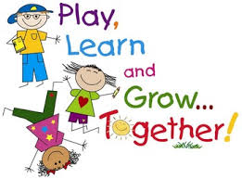
ENGLISH 4th Grade 1st June

Good morning!!! How are you? Not tired of English yet?

Here you have more activities!

REMEMBER : DON’T SEND THE HOMEWORK, just keep it

1. ACTIVITY 3 : WATCH THE STORY The animal in the tree

https://elt.oup.com/student/amazingrooftops/level04/stories?cc=global&selLanguage=en#tracktitle

Complete :
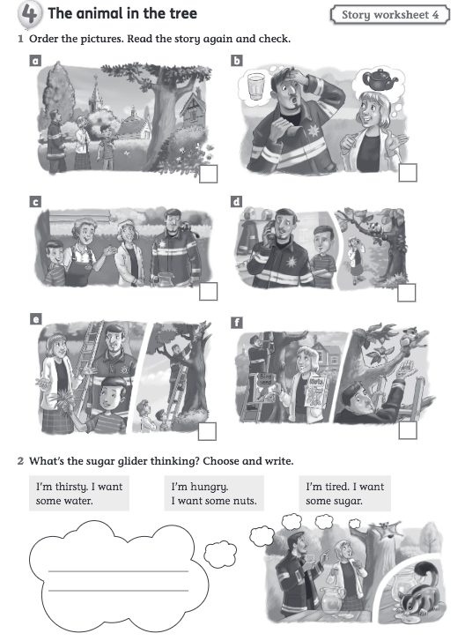

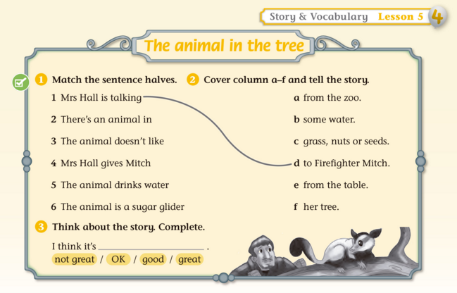
* Remember: the word “from “ means “ de, des de”

2. GAMES to practice on-line.
Ask the questions and find the animal

https://www.gamestolearnenglish.com/animal-mystery/

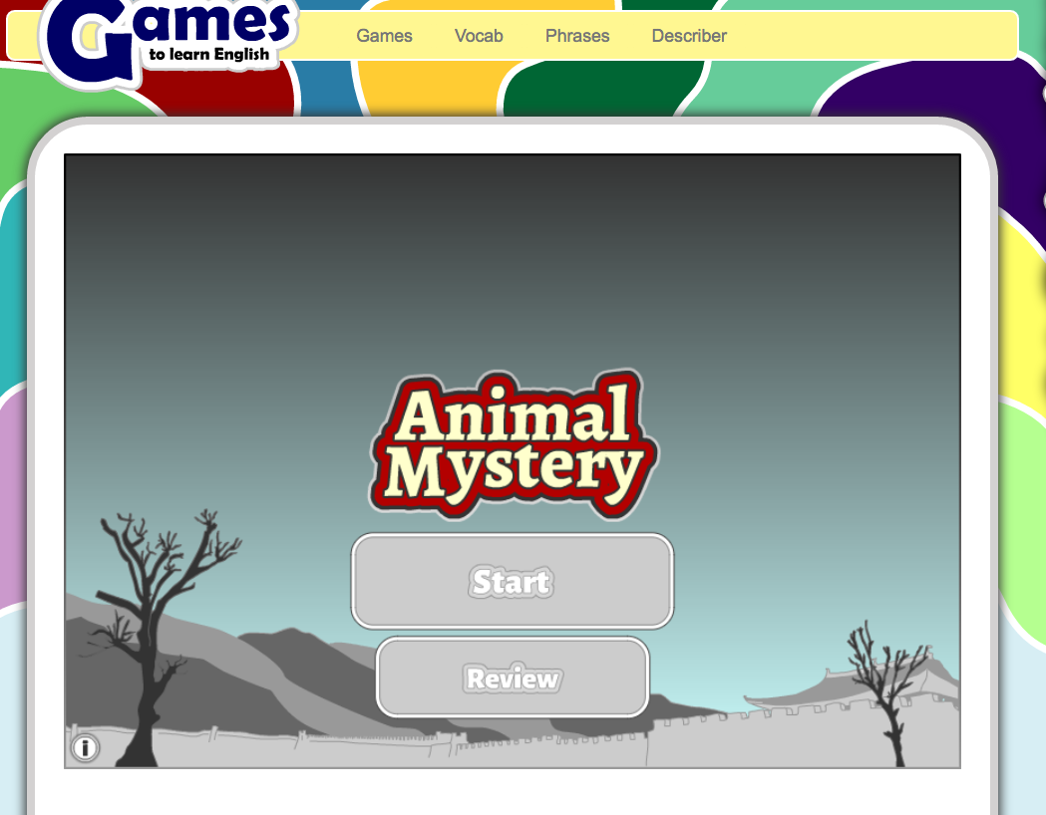

3. ACTIVITY 3 : Listen to a poem . It tells you about a dog .

https://www.kennnesbitt.com/mp3/MyDogPlaysInvisibleFrisbeeMixdown.mp3

Listen again and complete the next page. Study the vocabulary on the pictures.

Read this poem . It tells about a dog
Listen and fill in the blanks with the words from the box. Complete the last line
( it’s not in the box )
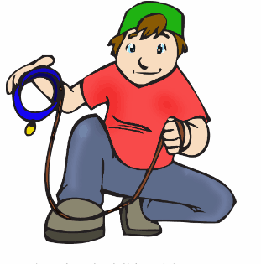
balls- tricks - slippers – squirrels – go – barks – Frisbee – walls – hats – clearly – skateboard- cats - jumps- sticks

My dog plays invisible ______________.
He catches invisible _____________.
He rides an invisible _______________.
He hurdles invisible _____________.
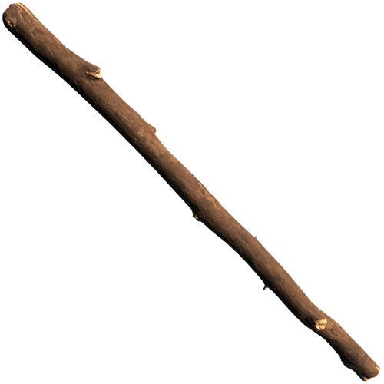
My dog has perfected the practice
of doing invisible ____________.
He __________ with invisible jumpropes
and fetches invisible __________.
A Frisbee
slippers
He _________ at invisible mailmen.
He growls at invisible _______.
He’ll bring me invisible ___________
and even invisible __________.
a stick
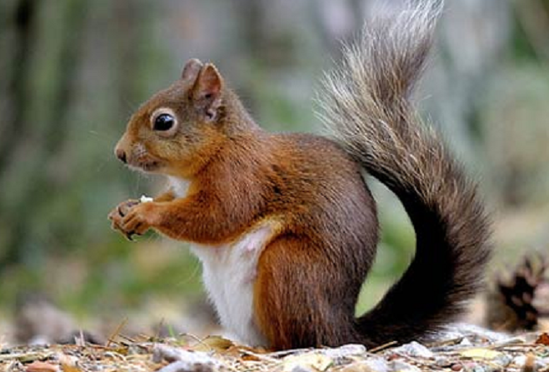
He chases invisible ___________
whenever we _________ for a jog.
He’s ___________ the greatest dog ever.
___ ________ ____ _____________ ____ .
a jumprope
Kenn Nesbitt

a squirrel
a bike trick
a magic trick
a jog

HAVE A NICE WEEK !
a wall

