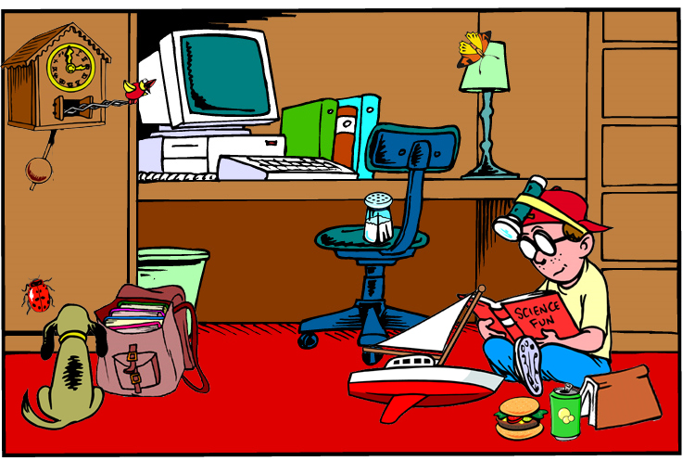
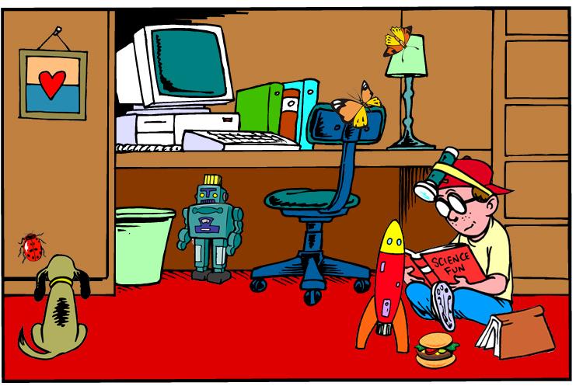


Look at the two pictures of the room. Circle as many differences as you can and then write the differences below.
(1) | There is a painting in the wall.
 | There is a clock in the wall.
(2)
(3)
(4)
(5)
(6)
(7)

