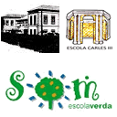
YEAR 6 Session 16 EUROPEAN COUNTRIES WORLD RECORDS.
What’s your name? Class: year 6___
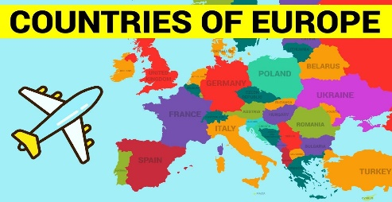
Answer the questions or ask a question .

1-.What is the highest mountain? The highest mountain is Write your answer

2-.How high is Mount Blanc?Write your answer

3-. Which is the longest river? Write your answer

4-. Write your question ? It’s fish and chips and Sunday roast.

5-.How ___adjective___is river Severn? Write your answer

6-. Write your question ? It’s 3.364 metres long.

7-.Which is the capital city of Holand? Write your answer

8-. How old is Notre Dame? Write your answer

9-.Is river Vistula in Poland longer than river Po in Italy? Yes it is/ No it isn’t

10-.What is your favourite country in Europe? Write your answer

