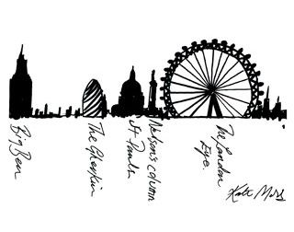

YEAR 6 Session 11 THIS IS LONDON
NAME AND CLASS:
DATE:
ACTIVITY 1-. Watch this video about London in Youtube

https://www.youtube.com/watch?v=P2WQBD6nNY4&t=344s
2_ Open the document with Google docs and save it with your name Or Print the activities 

ACTIVITY 2
Circle the things/objects you see in the video.


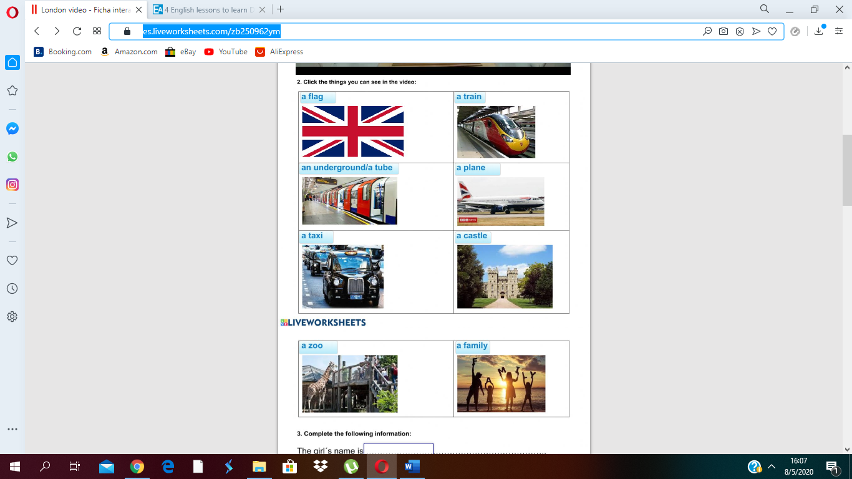
2
2-
. ACTIVITY 3

- Complete the following information.

The girl’s name is

The boy’s name is

They are in America or Great Britain
By
The family go to Buckingham Palace by train/ by bus/ by taxi

The tickets cost £40 / £50 / £60

Hamleys is a

NAME AND CLASS
ACTIVITY 4
Look, read and match
- Nelson’s Column *is a river.
- London Eye *is the name of the bell.
- Big Ben *is a big wheel.
- The Houses of Parliament *is a monument.
- The Tames *is the place where the Prime Minister
Works.
- The Buckingham Palace *is a castle.
- The Tower of London *is the place where the Queen lives.


ACTIVITY 5
- Search on the internet and write the answers. If you need it, use the online dictionary www.wordreference.com

- How long is the River Thames? vmfm
- Who is the major of London? sfhsh
- Who is the Prime Minister? vmfm
- Where does the Prime Minister live? vmfm
- Which is the UK currency? vmfm
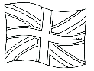
- What is the name of red buses? vmfm
- What is the name of this flag? vmfm
- Which is the most traditional dish in London? vmfm
- What happens at 5 o’clock? vmfm
- Say one traditional sport in UK. vmfm

