DEURES D’ESTIU
LLENGUA ANGLESA
6è D’EDUCACIÓ PRIMÀRIA

NOM I COGNOMS
NOM DE L’ESCOLA

Indicacions de com treballar aquest dossier.
Aquest dossier recull unes quantes activitats que t’ajudaran a repassar i preparar la teva presentació quan arribis a l’ Institut. És un dossier obligatori i l’hauràs de lliurar al teu professor el primer dia de classe.
Les activitats que trobaràs es troben diferenciades per competències orals (listening) i competències escrites (reading and writing).
Et recordem que per fer qualsevol activitat és important que entenguis que se’t demana fer i que pots fer servir el diccionari sempre que et calgui. A les activitats de “reading” hauràs de buscar la resposta correcta al text. Per trobar la resposta correcta, intenta subratllar al text el fragment correcte de la pregunta.
Al final del dossier també hi trobaràs un seguit de webs amb activitats que pots realitzar de manera optativa.
D’altra banda també pots fer totes les activitats que et vinguin de gust, com ara:
- Repassar el CD del llibre d’activitats d’aquest curs.
- Escoltar música en anglès.
- Mirar alguna pel·lícula en anglès.
- Posar subtítols en anglès a les teves sèries preferides.
- Llegir revistes o petits llibres en anglès.
- Escriure un diari (3 – 4 línies) sobre el que fas a les vacances. No cal que sigui cada dia, però si el màxim de dies possibles.
- Fer un PORTFOLIO (llibreta amb imatges) de les paraules que vas aprenent durant aquest estiu. Et serà molt útil i el podràs continuar utilitzant a l’institut.

Esperem que aquest dossier et sigui d’ajuda.

RECORDA: Aquest dossier s’ha de lliurar a l’institut el primer dia de clase al tutor i es tindrà en compte per a l’avaluació del primer trimestre.

- Listening activities

Activity 1: EATING OUT
Link: http://learnenglishteens.britishcouncil.org/skills/listening-skills-practice/eating-out
- Do this exercise before you listen. Write the name under each picture.
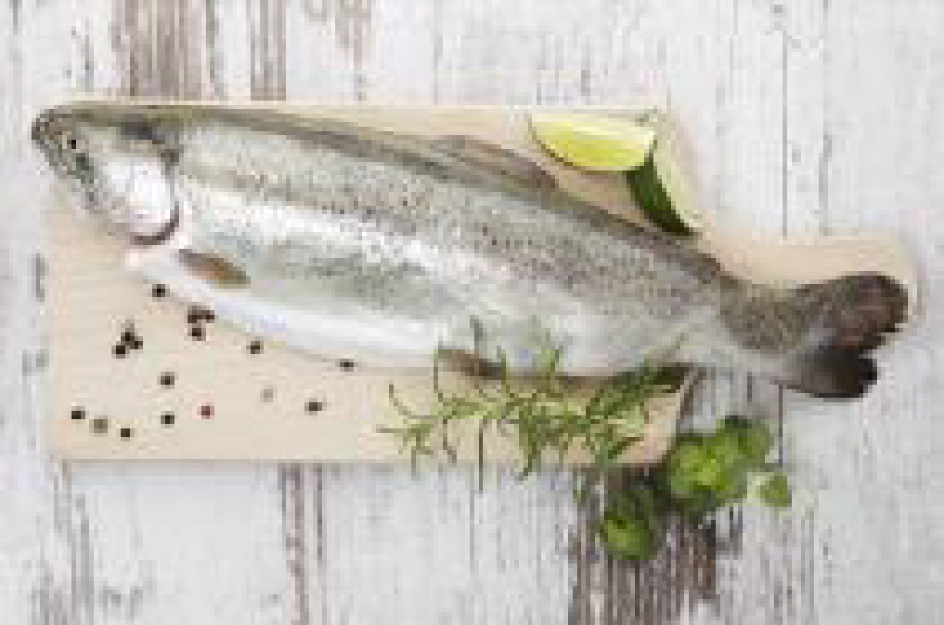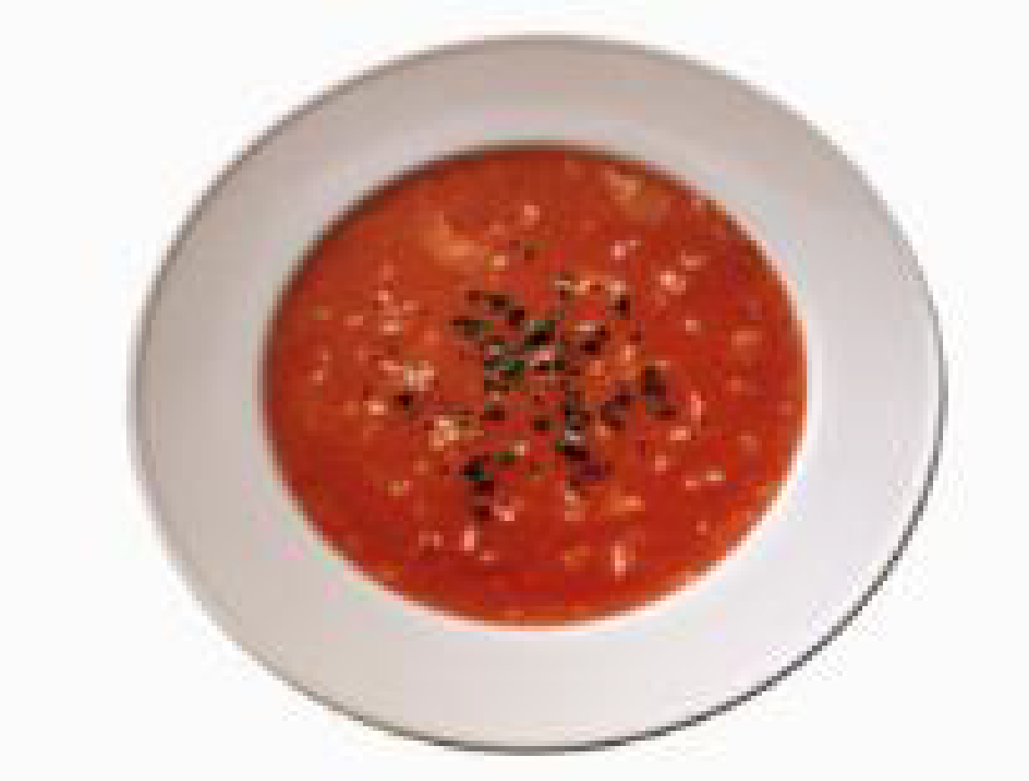
__________ ___________ ______ ____________

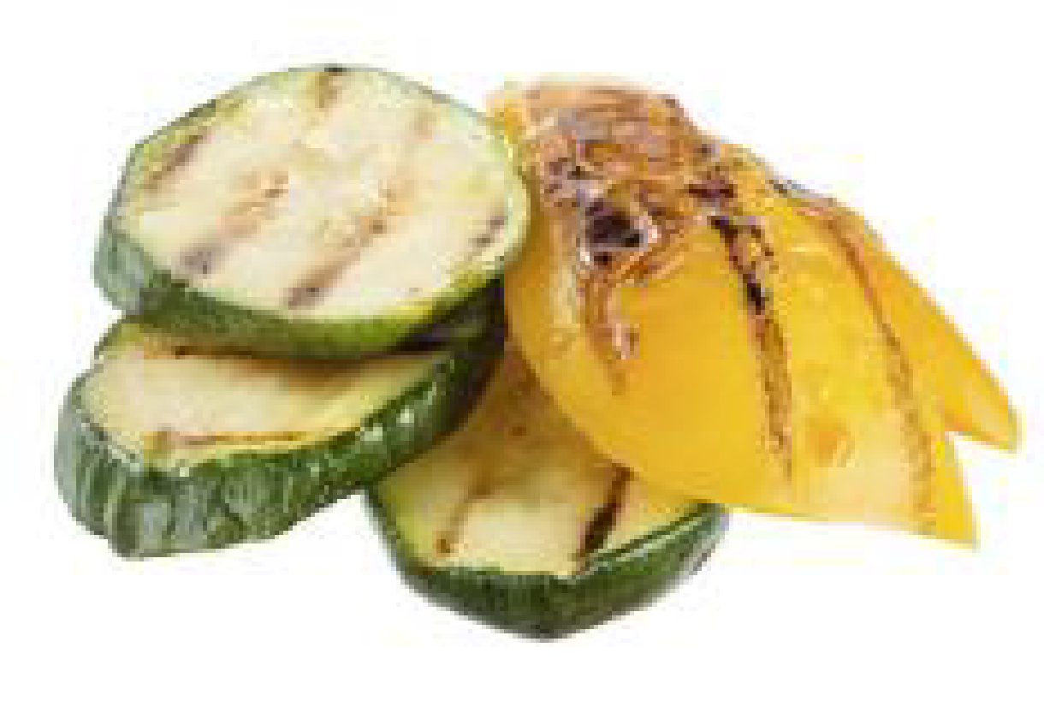
___________ __________ __________ ____________
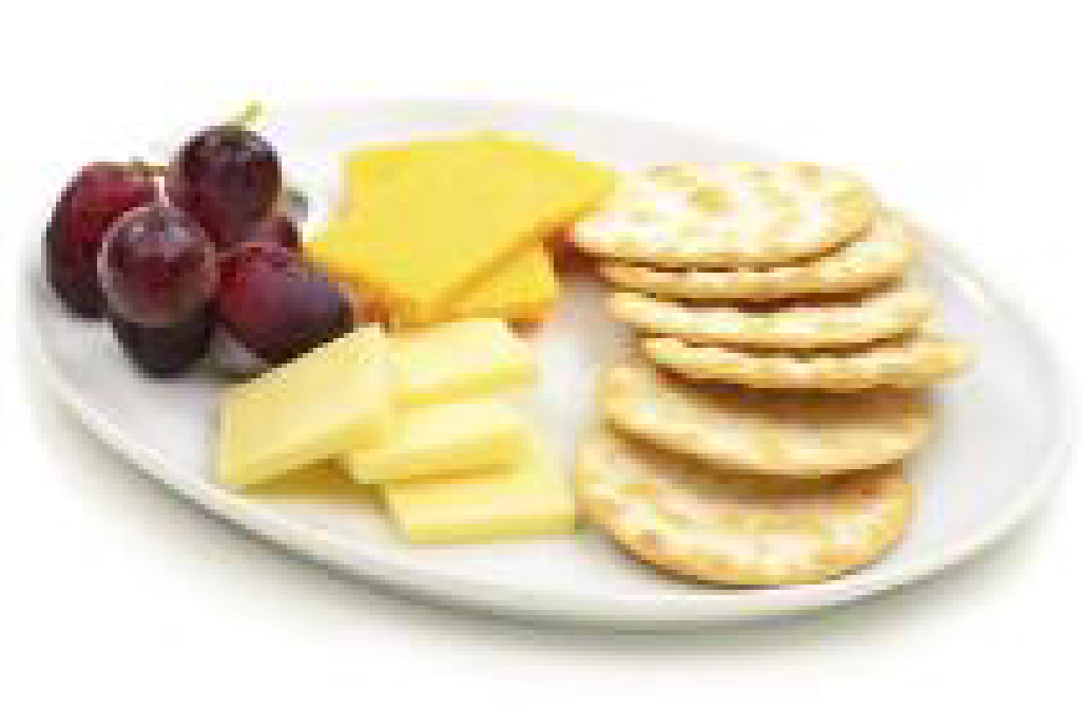
___________ ____________ ____________ ____________

Fruit salad cheeseburger vegetables cheese and biscuits ice cream pasta
Chips roast chicken sausages tomato soup omelette grilled fish

- Do this exercise while you listen. Circle True or False for these sentences.
1 –The customers want two tables. True False
2 –There are two customers eating together. True False
3 –The two customers order the same starter. True False
4 –Both customers order the Thai chicken for their main course. True False
5 –The customers order cold drinks True False
6 –Both customers order a dessert True False

- Do this exercise while you listen. Complete the gaps with a word from the box.

1 –A table _____________________ two, please.
2 – Are you ready __________________ order?
3 – What would you _________________ for your starter?
4 –I’d ____________________ French onion soup, please.
5 –What __________________ you like to drink?
6 – I’ll _____________________ a fresh orange juice.

Activity 2: MY FAVOURITE DAY – CHINESE NEW YEAR
Link : http://learnenglishkids.britishcouncil.org/en/short-stories/my-favourite-day-chinese-new-year
- Match them up! Draw a line to match the picture and the word.
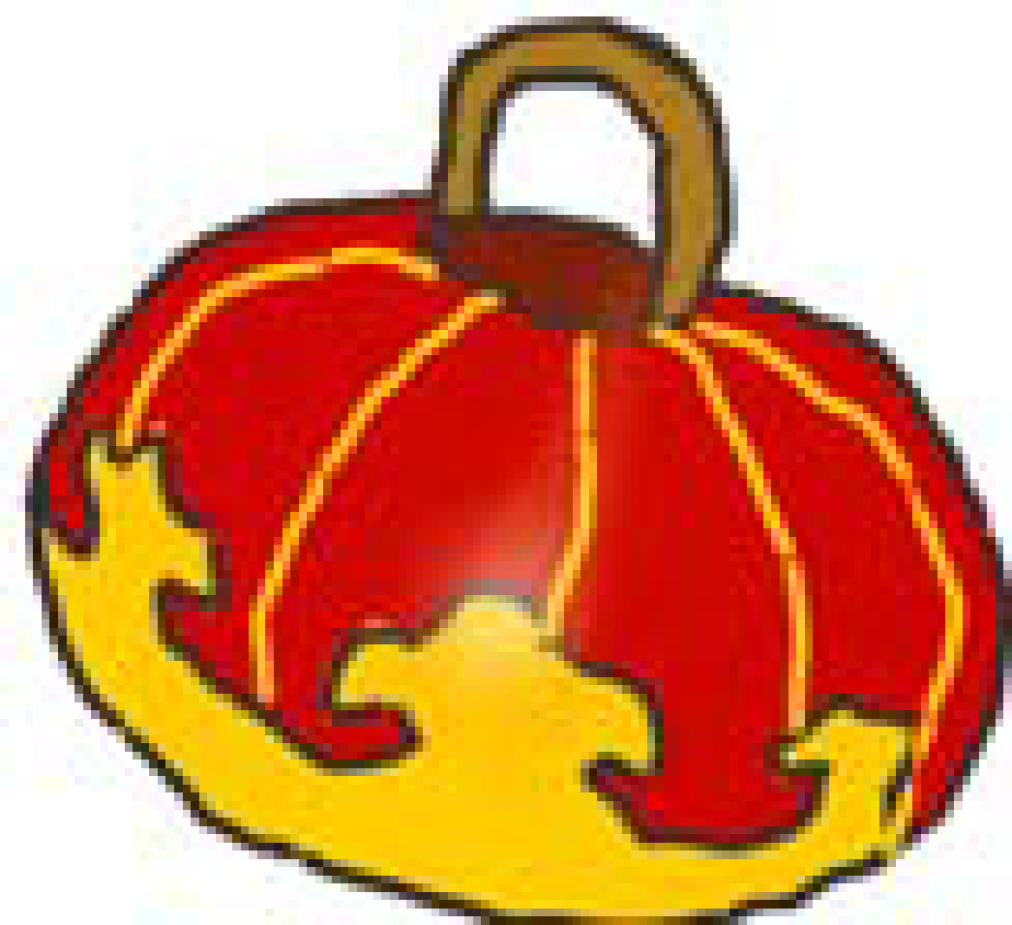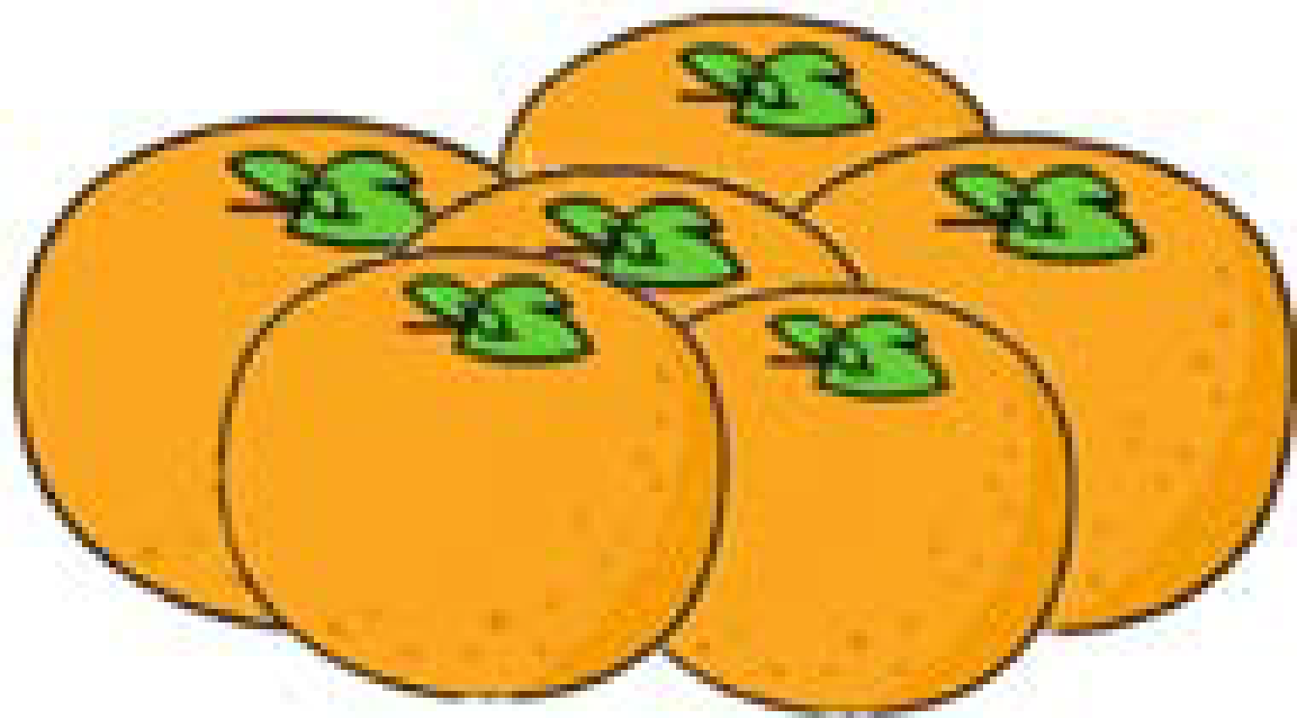

Lantern lion dance oranges red clothes red envelope

- Choose the answer! Read the sentence. Choose the correct answer.
a. The Chinese New Year festival lasts for _____________ days.
ten fifteen twenty

b. At midnight, every door and ______________ is opened.
shop cupboard window
c. On the last day, we carry_______________ in a parade at night.
lanterns torches candles
d. Two people dance under a bright ______________ costume to bring good luck.
tiger lion leopard
e. People wear bright, red _________________ to bring a happy future.
shoes hats clothes
f. We take________________ and tangerines if we visit someone’s home for luck.
apples bananas oranges
g. Children and relatives are given red _________________ with ‘lucky money’ inside.
Wallets envelopes folders

Activity 3: THE COLD PLANET
Link : http://learnenglishkids.britishcouncil.org/en/short-stories/the-cold-planet
- What’s the word? Write the word under the pictures.
sun planet alien torch
batteries beam of light mirror ice cream
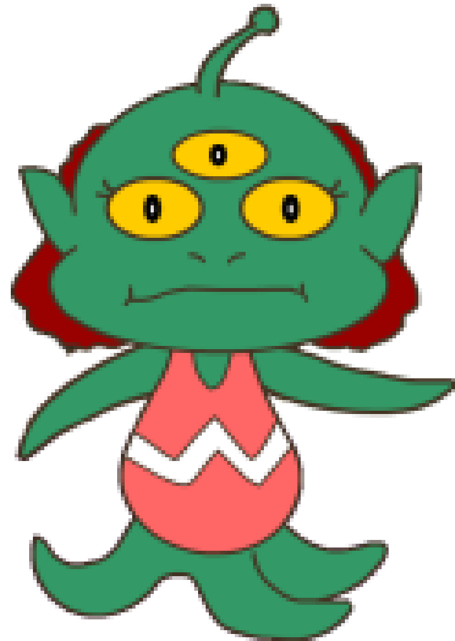
__________ ____________ ___________ ___________
_________________ ______________ _______ ________

- What’s the order? Listen to the story and put the sentences in order.
__ Neila was sad, but Billy said he would help her.
__Now Neila and her friends can sit in the sun and eat ice cream.
__ Neila is an alien who lives on a planet made of ice cream, called Fliptune.
__The beam of light hit Billy and his dog, Splodge. They flew to Fliptune.
__ Billy and Splodge went back to Earth.
__ One day she put the wrong batteries in her torch. It sent out a beam of light.
__ Billy’s mirror sent sunshine to the planet Fliptune.

- Choose the answer! Read the sentence. Circle the correct answer.

- Fliptune is _____________ and cold. dark / light / dangerous
- The aliens use ____________ to see. candles / torches / lights
- Neila put the wrong _____________ in her torch. power / bulb / batteries
- Splodge thought the ice cream would melt in his ______________. paw/head / tummy
- Fliptune needed ___________ to make things grow. snow/sunshine / water
- Billy’s __________ mirror sent sunlight to Fliptune. Bedroom / bathroom / kitchen
- Now Neila and her friends can eat the _____________. Fruit/ice cream/chocolate

Activity 4. : Listen to Madonna’s song (Give me all your love) and fill in the gaps.

L-U-V Madonna
Y-O-U You wanna
I see you coming and I don't wanna know (1)_____________ name
L-U-V Madonna
I see you coming and you're gonna have to change the game
Y-O-U You wanna
Would you like to try?
Give me a reason why
Give me all that you got
Maybe you'll do fine
As long as you don't lie to me
And pretend to be what you're not
(CHORUS)
Don't (2) __________ the stupid game
Cause I'm different kind of girl
Every record sounds the same
You've got to step into my world
Give me all your love and give me your love
Give me all your love today
Give me all your love and give me your love
Let's forget about time
And dance our lives away
L-U-V Madonna
Y-O-U You wanna
Ke L-U-V Madonna
Keep trying don't give up, it's if you want it bad enough
L-U-V Madonna
It's right in front of you, now tell me what you're thinking of
Y-O-U-You wanna
In another place, at a different time
You can be my lucky star
We can (3) _________ some wine
Burgundry is fine
Let's drink the bottle every drop
(CHORUS)
Don't play the stupid game
Cause I'm a different kind of (4) _______________
Every record sounds the same
You've got to step into my world
Give me all your love and give me your love
Give me all your love today
Give me all your love and give me your love
Let's forget about time
And (5) _____________ our lives away
(BRIDGE)
You have all the L-U-V
I gave you (6) ______________ you need
Now it's up to Y-O-U
Are you the one, shall we proceed?
M-A-D Don't make me
L-U-V It's time for
Y-O-U It's up to
L-U-V I want your
(CHORUS)
Don't play the stupid game
Cause I'm a different kind of girl
Every record sounds the same
You've got to step into my (7) __________________
Give me all your love and give me your love
Give me all your love today
Give me all your love and give me your love
Let's forget about time
And dance our lives away

- Reading activities
Activity 1: Read the text and answer the questions. Look at the dictionary if necessary.

Do tigers like monkeys? Tigers are big cats that eat meat.
Below is a picture of Dema the tiger and Nia the Monkey. Both of these baby animals do not have a real family, so they wanted to be friends.
The tiger and the monkey love to play with each other. They play with toys and take naps
together. Then, one morning, Nia gave Dema a hug, and Dema licked and kissed him back!
They are great friends.

🗐 Read the story. Use the information in the story to answer the questions below.

- Tigers are big cats that eat _____________.
a. Grass.
b. Meat.
c. Beans.
d. Tigers.

- In this story, what are the names of the tiger and the monkey?
a. David and Nancy.
b. Dad and Mom.
c. Dema and Nia.
d. Dragon and Night.

- Why did the tiger and the monkey want to be friends?
a. They did not have a real family.
b. They did not like each other.
c. They did not have fun together.
d. They were hungry.

- What did Dema and Nia do fun for?
a. Play video games.
b. Watch TV.
c. Go hunting for food.
d. Play with toys and take naps.

- Nia gave Dema a hug. Then what did Dema do to Nia?
a. Hugged him back.
b. Licked him back.
c. Licked and kissed him back.
d. Run away.

Activity 2: Read the text and answer the questions. Look at the dictionary if necessary.
Delicious Jamaican coffee
A few kilometres North of Kingston, Jamaica’s capital, you can visit the Blue Mountains. It’s the highest and longest mountain range on the island. When Columbus discovered it in 1494 it was full of trees. Today, the rainforest is much smaller and there’s a national park to protect the trees that are left.
People use the lower parts of the Blue Mountains, that haven’t got any trees, to grow vegetables, spices and the world-famous Blue Mountain coffee. Sir Nicholas Lawes, an important British politician in Jamaica, was the first to bring coffee to the island in 1728. In the early 19th century, Jamaica was the most important coffee producer in the world. Today there are other countries that produce more coffee, including Brazil, Vietnam and Colombia.
Blue Mountain coffee is one of the most expensive coffees in the world, and about 80 per cent of it goes to Japan each year. The weather in the Jamaican mountain range is perfect to grow delicious coffee beans; it’s cool with a lot of rain. Jamaica also grows other things and sells them around the world, such as sugar and bananas.
1)The Blue Mountains are near…
a)the Caribbean. B)Kingston. C) Jamaica.
2)What was bigger in 1494 than it is today?
a) the rainforest. B)The mountain range C)the national park.
3) There aren’t any……at the bottom of the Blue Mountains.
a)spices. B)vegetables C)trees.
4) About 200 years ago,…….produced more coffee then other countries.
a)Brazil. B)Jamaica. C)Columbia.
5) Jamaican coffee is very expensive because…..
a)the weather makes it very tasty. B)Japan buys most of it.
c)the island only produces coffee, sugar and bananas.

Activity 3: Read the text and answer the questions. Look at the dictionary if necessary.
Hi, Tomas!
Can I be your new pen friend? I’m Edward. My friends call me Ed. I live near Newcastle, in England, with my parents and my six years old sister, Susan. I live in a palace called Heaton,near Newcastle University. If you want to write to me, my address is: 16, Hill Street, Heaton, Newcastle upon Tyne, England. If you want to email me, my email address is edisking@tallmail.com.
Newcastle is a busy city and there’s a lot to do. There’s a big shopping centre called Eldon Square with cinemes, shops and restaurants. I sometimes go there at the weekend with my family. I save my pocket Money to buy video games there too.
My Birthday is on the fifteenth of October. My hobbies are playing the guitar and football. I suport Newcastle United. My favourite Player is Andy Carroll.
What about you? Where do you live? What’s your address? What are your hobbies? What sport do you like?
Looking forward to hearing from you,
Edward

- What do Edward’s friends call him?
  - Ted
  - Ed
  - Id

- Where does Edward live?
  - House
  - Flat
  - Palace

- What is his address?
  - 16, Hill Street, Heaton
  - Carrer Cirerer, 15, Cornellà
  - 23, Boston Street, London

- What is his email address?
  - marta@hotmail.com
  - pepito@gmail.com
  - edisking@tallmail.com

- What does Edward like to buy?
  - Sweets
  - Video games
  - Books

- When is Edward’s birthday?
  - on the fifteenth of October
  - on the nineteenth of March
  - on the fifth of January

- What football team does he support?
  - FCB
  - Real Madrid
  - Newcastle United

- Who is his favourite footballer?
  - Cristiano Ronaldo
  - Andy Carroll
  - Leo Messi

- Writing activities
Activity 1: Answer the questions about you. Then, write about you. Look at the dictionary if necessary.
Who are you?
How old are you?
Where are you from?
Where do you live?
Who is in your family? Parents, brothers, sisters....
Have you got straight, long, brown hair?
Have you got blue, big eyes (Physical description)
Have you got any pet? What’s its name? ....
What are your hobbies? Are you good at......?
What do you do in your free time?
What do you like?
What do you don’tlike?
What’s your favourite school subject?
Are you good at ...?
How many languages do you speak?
Are you good at English?
Other information....
_________________________________________________________________________
_________________________________________________________________________
_________________________________________________________________________
_________________________________________________________________________
_________________________________________________________________________
_________________________________________________________________________
_________________________________________________________________________
_________________________________________________________________________
_________________________________________________________________________
_________________________________________________________________________
_________________________________________________________________________
_________________________________________________________________________
_________________________________________________________________________
_________________________________________________________________________
_________________________________________________________________________
_________________________________________________________________________
_________________________________________________________________________

Now you can draw a picture of you !!

Activity 2: Look at the picture and write all what children are doing. Look at the dictionary if necessary.

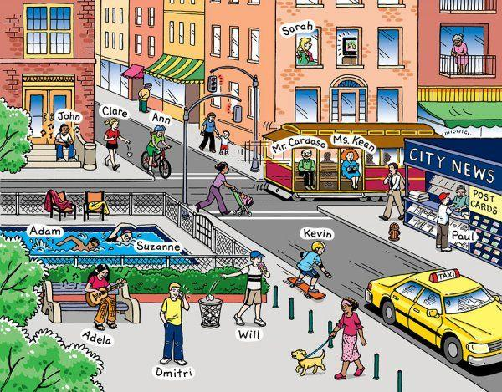

Example:
Adela is sitting on a bench playing the guitar and next to her Dimitri is calling a friend.
Suzanne and Adam are………………………………………………………………………………
…………………………………………………………………………………………………………………
…………………………………………………………………………………………………………………
…………………………………………………………………………………………………………………
…………………………………………………………………………………………………………………
…………………………………………………………………………………………………………………
…………………………………………………………………………………………………………………

- Grammar activities
Activity 1: Read the example. Look and write sentences with the correct adverbs of frequency.

X never | √ sometimes | √√ often | √√√ usually | √√√√ always

 | James | Steven | Mary | Rachel
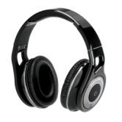 |  | √ | √√√ | x
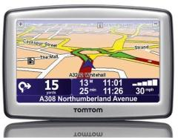 | √√ |  | x
 | x | x | √ | √√√
 | √√ | √√√ | √√√√ | √
 | √ | √√
 | √√√√ |  |  | √√√√
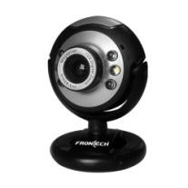 |  | √√√√ | √√ | √

- Rachel/ use/ her tablet
Rachel usually uses her tablet.
- Mary/ use/ satnav
________________________________________________
- Steven/ use/ webcam
_________________________________________________
- Rachel/ listen to music/ with headphones
_________________________________________________
5) James/ take/ his video games console/ to parties
_________________________________________________

Activity 2. Look at the example. Then look and complete the sentences using the comparative adjectives and than.

Bob | Tom

- Tom has got darker hair than Bob.

- Bob is ___________________ Bob. (old)

- Tom has got ____________________ Bob. (long hair)

- Tom is ___________________ Bob. (happy).

Activity 3. What did Ana and Pau did in London last summer? Look at the example. Write questions, then look and circle the correct answers.
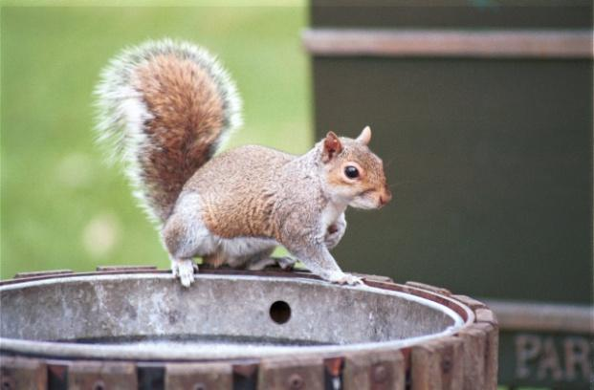
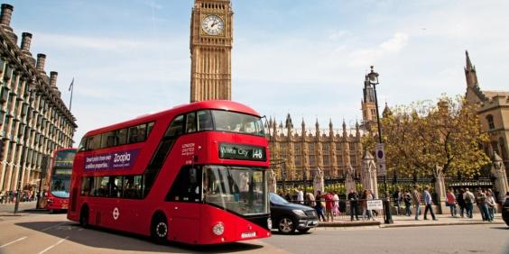

- they/ travel by bus?
Yes, they did

Did they travel by bus? / No, they didn’t.
- Ana/ take a picture?

________________________ Yes, she did. / No, she didn’t.

- they/ see a squirrel?

________________________ Yes, they did/ No they didn’t.

- they/ take the underground?

________________________ Yes, they did/ No they didn’t.
- Websites for activities
🖰 Reading and writing
http://www.edu365.cat/primaria/muds/angles/friends/in007_es/index.html

Activitats al voltant del vocabulari dels esports i les activitats de lleure.
http://www.edu365.cat/primaria/muds/angles/friends/in016_es/index.html

Activitats per practicar allò que sabem o no sabem fer.
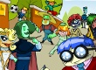 | http://www.edu365.cat/primaria/muds/angles/friends/in028_es/index.html  Activitats per practicar el vocabulari relacionat amb les professions.
http://www.edu365.cat/primaria/muds/angles/friends/in008_es/index.html

Activitats per practicar com diem allò que fem en aquest moment.
http://www.edu365.cat/primaria/muds/angles/friends/in025_es/index.html

Activitats al voltant dels noms dels països i les nacionalitats.
http://www.edu365.cat/primaria/muds/angles/friends/in029_es/index.html

Activitats per practicar vocabulari relacionat amb les pel·lícules i com dir les pel·lícules que m’agraden i per què.
http://www.edu365.cat/primaria/muds/angles/friends/in013_es/index.html

Activitats per aprendre a dir allò que m’agrada i que no m’agrada.
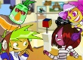 | http://www.edu365.cat/primaria/muds/angles/friends/in026_es/index.html  Activitats per practicar parlar i escriure sobre la meva vida i la dels que m’envolten.
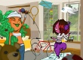 | http://www.edu365.cat/primaria/muds/angles/friends/in030_es/index.html  Activitats per parlar i escriure sobre els que faig durant el meu temps lliure.
http://www.billybear4kids.com/TinyTitles/TinyBooks.html

Plantilles per escriure els teus propis llibres de festes i festivitats.

🖰 Reading and listening
http://www.esl4kids.net/songs.html

Cançons en anglès per escoltar i aprendre.
http://www.bbc.co.uk/schools/wordsandpictures/longvow/poems/fpoem.shtml

Poemes per llegir i escoltar. També hi ha propostes d’activitats a fer.
http://www.bbc.co.uk/schools/laac/story/sbi.shtml

Llibres per llegir i escoltar.
http://www.bbc.co.uk/cbeebies/stories/

Històries per llegir organitzades per temes.
http://www.storyplace.org/preschool/activities/bellawear.asp?themeid=2

Històries per escoltar amb activitats per fer.
http://www.magickeys.com/books/index.html

Històries de nivells diferents per llegir. Algunes inclouen àudio.
🖰 To learn about some different topics.
http://www.enchantedlearning.com/subjects/dinosaurs/
Pots llegir i aprendre coses sobre dinosaures.
http://www.enchantedlearning.com/subjects/mammals/
Per aprendre sobre mamífers.
http://www.enchantedlearning.com/subjects/volcano/

Per aprendre sobre volcans.
http://www.enchantedlearning.com/subjects/rainforest/

Per aprendre sobre la selva i les zones tropicals.
http://www.enchantedlearning.com/subjects/astronomy/activities/radiobuttonquiz/

Per aprendre sobre astronomia a partir de jocs.

