Treasure hunt: The instruments of the orchestra
Introduction
What instruments make up an orchestra? How are they organized? And what exactly does a conductor do? You can find all these answers in the following treasure hunt!
Questions
Look at this page http://www.classicsforkids.com/music/orchestra.asp and answer the following questions:
- What’s an orchestra?
- How is the orchestra divided?
- Who leads this group of musicians?
- Paint each section of the orchestra in the following colours:
Strings section: yellow
Woodwind section: pink
Brass section: green
Percussion section: blue
Conductor: red
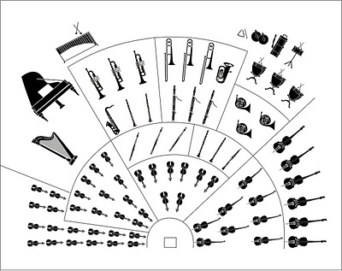

The string section
- How does the string section make their sound?
- Fill in the gaps with the correct verbs: The strings are ___________ the hollow body of the instrument and ______ or __________ with a bow.
- How is the pitch changed? Can you mime it?
- Put the name of the instruments which form the string section:
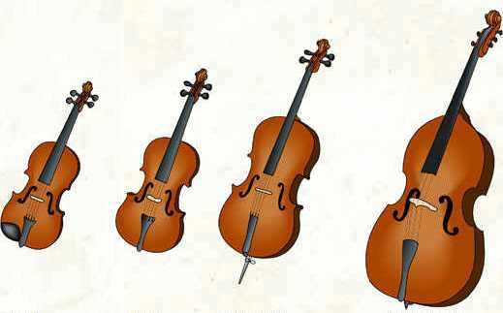

The woodwind section
- What are woodwind instruments made of?
- How is the sound made?
- How is the pitch changed?
- Put the name of the instruments which form the woodwind section:
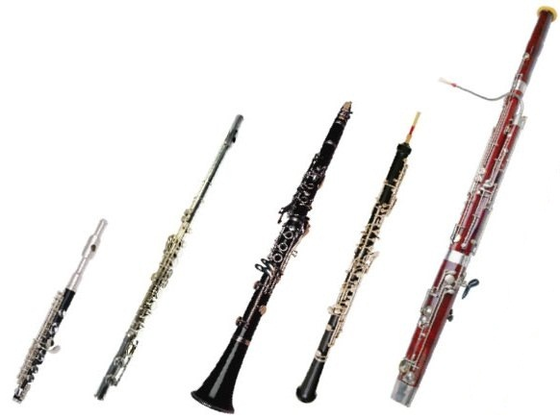

The brass section
- Translate brass into Catalan:
- What are brass instruments made of?
- Draw a cupshaped mouthpiece.
- Complete: the ____________ creates a ________________ column of air __________
the _________ of the instrument by ___________________ his or her ____________ together in the ________________________ and _________________air __________ between them, as if they are _____________________ a __________________sound.
- Put the names of the instruments which form the brass section:
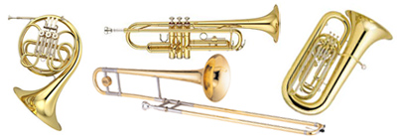

The percussion section
- How are percussion instruments played?
- Put the names of these instruments of the percussion section:
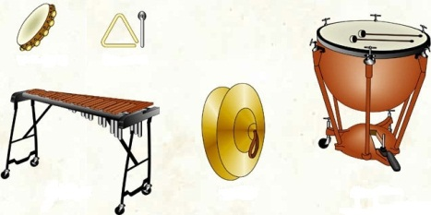

Now you know the instruments of the orchestra, but… are you able to recognize them by listening?
http://www.dsokids.com/listen/instrumentlist.aspx
- Listen to the music and put the names of the instruments which you hear:
Track | Instrument | Section
1
2
3
4
5

