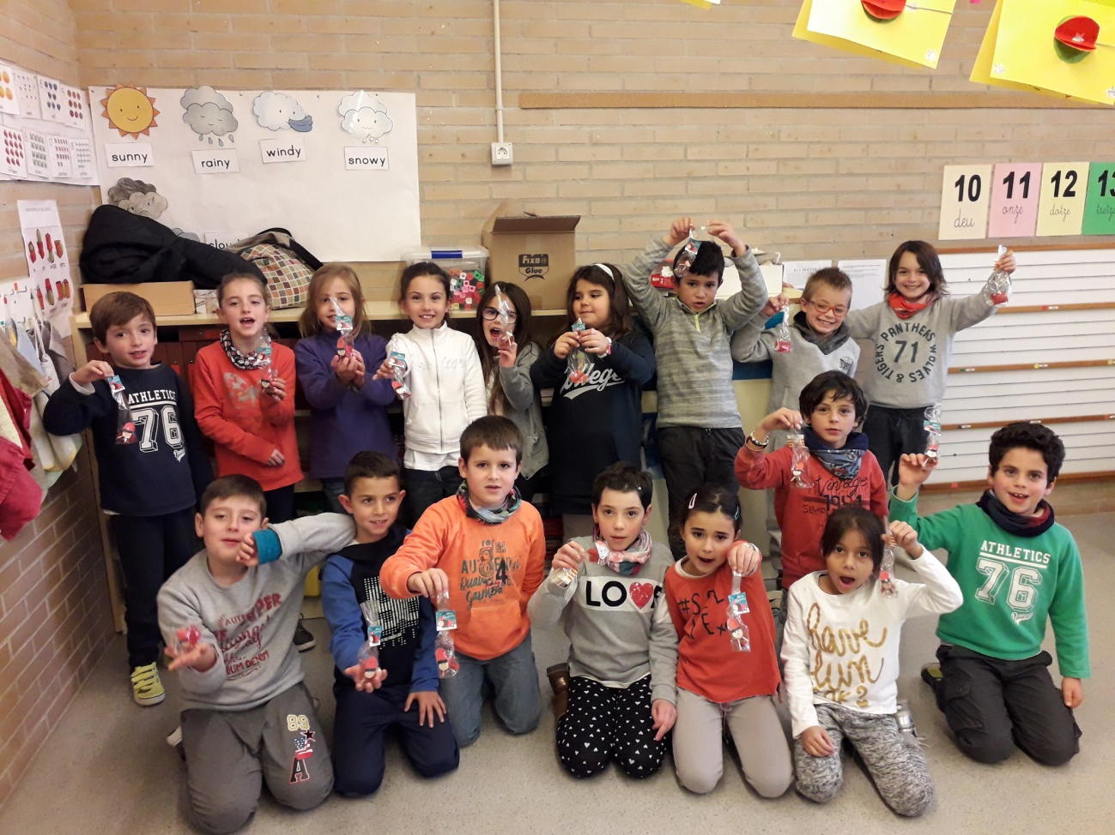

MERRY CHRISTMAS 2017 FAMILIES.

WE WISH YOU HAPPINESS AND JOY