Activitats de reforç d’estiu
6è de primària

English

Nom i cognoms:
Nom de l’escola:
Nom de l’institut:
Observacions del corrector:

INTRODUCCIÓ

El dossier que tens entre les mans és un recull d’activitats d’Anglès. Fer-les de manera reflexiva t’ajudarà a començar bé a l’Institut perquè et permetrà refrescar alguns dels continguts que has treballat a 6è.

És molt important que t’esforcis al màxim en la seva realització. Per això cal que escullis:

- Un bon moment per a fer les activitats (en el que estiguis tranquil/-la)
- Un espai que et permeti concentrar-te.

No oblidis que quan comencis 1r d’ESO el teu tutor/a et demanarà que presentis aquest dossier i, un cop corregit, te’l puntuarà com a treball de l’àrea.
No vulguis fer totes les propostes de cop, ni te les deixis per a l’últim dia...
Pensa que tens dos mesos per anar treballant i una bona planificació del temps t’ajudarà a que el resultat sigui òptim.
Per moltes de les activitats necessitaràs un ordinador amb connexió a internet. Pots utilitzar de manera gratuïta els ordinadors de les biblioteques públiques i dels centres cívics.
Si tens dubtes a l’hora de realitzar-lo o vols saber-ne més hi ha pàgines web que et poden ajudar molt, com www.edu365.com, http://learnenglishkids.britishcouncil.org/en També pots fer ús de diccionaris online (www.wordreference.com) o en format paper. També pots demanar ajuda a algun adult.

Esperem que tinguis un molt bon estiu i una millor entrada a aquesta nova etapa educativa!

Els teus i les teves mestres!

WRITING__________________________________________________

ACTIVITY 1
Answer the questions about you. Respon sobre tu.

- What’s your name? .....

- How old are you? I’m .....

- Where are you from? I’m .....

- Where do you live? I ……………………………in ………………

- Have you got any brothers or sisters? I’ve got ... ……………………….. or I haven’t got ....

- Have you got straight, long, brown hair? Have you got blue, big eyes (physical description)? I’ve got…..

- Have you got any pets? What’s its name? .....

- What are your hobbies? Ex. I play tennis. .....

- What do you like? (sports, food, colours, pets...) I like...

- What don’t you like? I don’t like...

- What’s your favourite school subject? Are you good at...?

Ex. My favourite school subject is English. I’m good at PE.

- How many languages do you speak? I...

Other information:
ACTIVITY 2
Write about yourself. Use your answers above

Llegeix l’exemple i escriu sobre tu. Utilitza les teves respostes anteriors.

Read the following example

My name is Victor. I’m twelve years old. I’m from Catalonia, Spain. I live in Barcelona. I’ve got a brother and a sister. My brother’s name is Rubén and my sister’s name is Blanca.

I’ve got short black hair and big brown eyes. I’m thin and tall. I haven’t got any pets. I usually play tennis and football.

I like playing computer games and I like reading science fiction novels! I like pasta, hamburgers and Chinese food. I don’t like chocolate or sweets. I like playing tennis and football. I don’t like swimming. My favourite school subject is English and I’m good at PE.

I speak two languages: Spanish and Catalan. And I’m learning English!

My name ..

LISTENING________________________________________________
ACTIVITY 3

Ves a http://www.eslvideo.com i clica la pestanya «beginning».

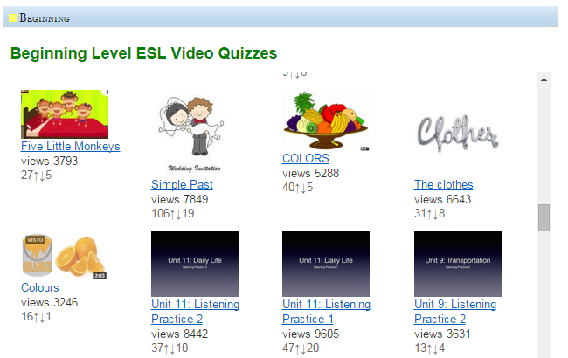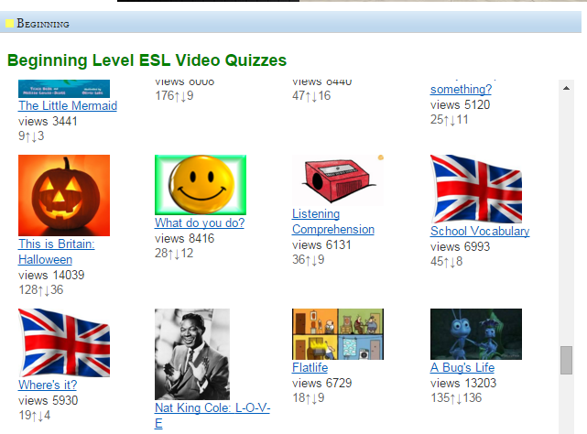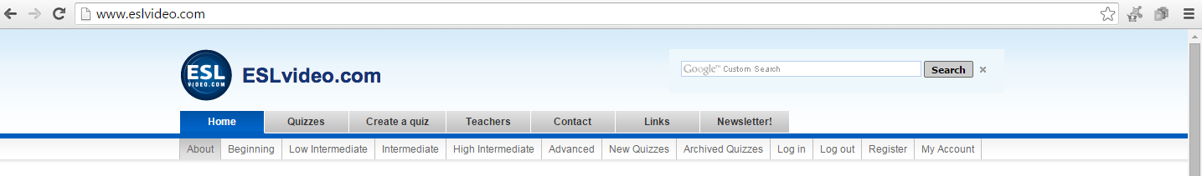
Busca Unit 11: Listening Practice 2 i This is Britain: Halloween

Questions: Listening Practice 2

Paulina wakes up at 6:00
- true.
- false

Paulina takes her children to school at 8:00.
- true.
- false

Paulina finishes English class at 12:00.
- true.
- false

Paulina eats lunch after class.
- true.
- false

Paulina picks her children up at 4:30.
- true
- false

Paulina and her children play outside before dinner.
- true
- false

Paulina cooks dinner at 6:00.
- true
- false

Paulina's children do their homework after dinner.
- true
- false

Paulina's children go to bed at 8:00.
- true
- false

Paulina goes to bed at 11:00.
- true
- false

Questions: This is Britain: Halloween

Where is Jack from?
- He is from Prague.
- He is from London.
- He is from Oxford.

When do people celebrate Halloween?
- On the 30th of October.
- On the 31st of November.
- On the 31st of October.

What is in the pumpkin lantern?
- There is a candle.
- There are matches.
- There is a ghost.

What is Sally making for the party?
- She is making scary pizzas.
- She is making pirate pancakes.
- She is making scary sandwiches.

What is Jack going to be at the party?
- A ghost.
- A wizard.
- A skeleton.

What special Halloween games are they playing?
- Orange bobbing.
- Trick or treat.
- Apple bobbing and apples on strings.

How many trick or treaters are at the door?
- There are two trick or treaters.
- There are five trick or treaters.
- There are three trick or treaters.

b) Ves a: www.kizclub.com i clicar la pestanya «STORIES & PROPS»
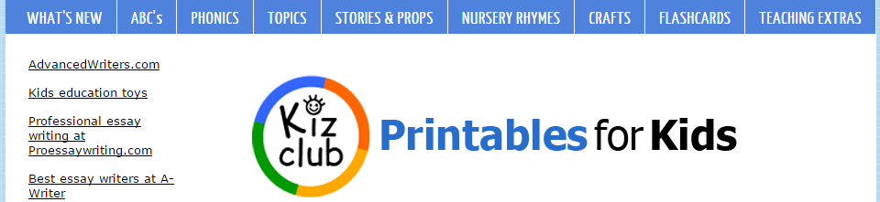
Clica la pestanya Level 1 i clica a «My week» 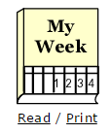
Clica la pestanya Level 2 i clica a «Feelings» 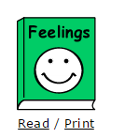

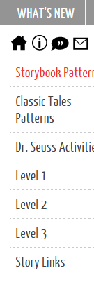

Questions: My week

What do you do on Mondays?
- I help my mom to shop.
- I water the plants.
- I watch TV.

Why do you go to the swimming pool?
- To play waterpolo.
- To go swimming.
- To meet some friends.

When do you go to the library?
- On Saturdays.
- On Wednesdays.
- On Fridays.

Who do you play baseball with?
- With my teachers.
- With my family.
- With my friends.

What do you do on Fridays?
- I walk my dog.
- I play football.
- I feed the birds.

What do you ride on Saturdays?
- I ride a horse.
- I ride a motorbike.
- I ride a bike.

What day do you go to the park?
- On Monday.
- On Sunday.
- On Tuesday.

Questions: Feeling

Does the face show how do you feel?
- Yes, it does.
- No, it doesn’t.

I feel happy when…
- I’m on holidays.
- My birthday comes near.
- I’ve got a sweet.

When I can’t play baseball I feel…
- Sad
- Happy
- Angry

Do you feel proud when you get a good grade in school?
- Yes, I do.
- No, I don’t.

I don’t like stories about ghosts because I feel…
- Hungry.
- Thirsty.
- Scared.

What happens when the toys get broken?
- I feel angry.
- I feel hungry.
- I feel happy.

WEBS RECOMENADES

Pots remenar aquestes webs

http://learnenglishkids.britishcouncil.org/enhttp://learnenglishkids.britishcouncil.org/en
http://www.edu365.cat/primaria/muds/angles/index.htmhttp://www.edu365.cat/primaria/muds/angles/index.htm
http://www.edu365.cat/primaria/muds/angles/index.htm
http://www.edu365.cat/primaria/muds/angles/index.htm
A quines web has entrat? Quins jocs/activitats has provat?

T’han agradat?

Què has après?

