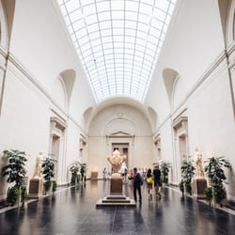
National gallery
The National Gallery is the main art museum in London, located on the northern boundary of Trafalgar Square in the municipality of Westminster, in the center of Greater London. Inaugurated in 1824, it has a collection of more than 2300 paintings, mostly European, of a wide historical period between 1250 and 1900. Because of its content it is a pinacoteca and not a generalist museum, as it does not exhibit sculptures or other arts, which are shown in other important museums of the capital.

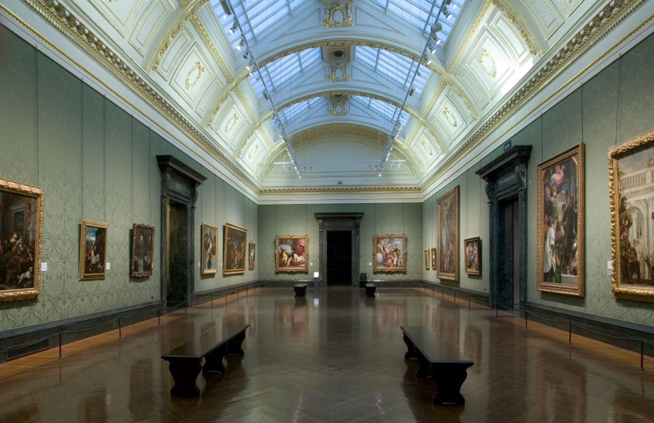
The sculptures and decorative arts are in the Victoria and Albert Museum; the British Museum houses archeology and drawings, mainly; and post-1900 art is exhibited at Tate Modern.

