Leicester Square
Leicester Square is a busiest pedestrian square in the west End of London, between Coven Garden and Piccadilly Circus, known by to be a place of cultural events and tourist attractions
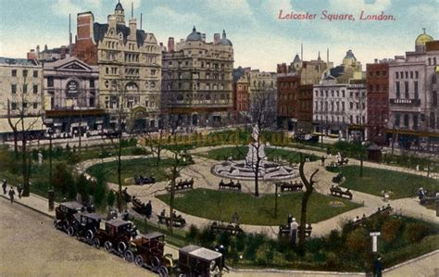
What can you see in Leicester square?
In the center of the square, there is a small garden with a statue of Williams Shakespeare surrounded of dolphins and their four corners many what represent to Isaac Newton and other personalities of the English life. More recently is added another statue of the actor and funny Charles Chaplin.
